Easy Recipes for Kids
Homemade Dog Treats


By Linda E. Brinser
Best-Dog-Treat-Recipes.com
© Copyright Best-Dog-Treat-Recipes.com 2010

Easy Recipes for Kids ebook
by Linda E. Brinser
https://best-dog-treat-recipes.com/

A Note to the Reader:

This ebook is intended to be used with children to help them learn to cook, and for other educational (and fun) purposes.

The recipes (created for dogs) have been tested and have safe ingredients--for both humans and dogs to eat.

This Easy Recipes for Kids ebook is copyrighted, but I would like to share it with others. So, if you have friends or family who would like a copy, please share it with them.

Easy Recipes for Kids
Homemade Dog Treats

Table of Contents
Easy Recipes for Kids ebook 2
Table of Contents 3
Introduction 5
Why Dog Treat Recipes? 6
Share Your Child’s Success 6
Cooking Tools 7
Healthy Dog Treat Ingredients 13
Just for Moms and Dads 15
Preschoolers and Young Children 15
Choosing a Recipe 15
Supervision 16
Measurements 16
Following Directions 16
Timing the Project 17
Happy Dog Anise Bar Cookies 18
Begging for Bananas Brownies 20
Pretend Chocolate Brownies 22
Doggie Energy Bars 24
Happy Tummy Gingerbread 26
Yummy Peanut Butter Brownies 28
Slim Jim Pumpkin Brownies 30
Good Boy Banana Biscuits 32
Bacon and Cheese Biscuits 35
Peanut Butter Dog Biscuits 38
Biscuits for Dogs with Allergies 41
Pumpkin Eater Dog Biscuits 44
Pretend Chocolate (Carob) Biscuits 47
Heavenly Anise Dog Bones 50
Apple Spice Dog Bones 53
Banana Dog Bones 56
Where’s the Beef Dog Bones 59
Berry Good Dog Bones 62
Peanut Butter Dog Bones 65
Crunchy Cheese Dog Bones 68
Carob Dog Bones 71
Chicken Bones 74
Applesauce Dog Cookies 77
Doggie Banana Cookies 79
Nutty Peanut Dog Cookies 81
Carob Chip Oatmeal Cookies 84
Bunny Chaser Carrot Cookies 86
Peanut Butter Oatmeal Cookies 88
Sunflower Seed Pumpkin Cookies 90
Whole Wheat Cranberry Dog Cookies 92
Carob Cookies 94
No-Bake Dog Cookies 96
Anise Cookie Press Cookies 98
Banana Cookie Press Cookies 100
Beefy Cookie Press Cookies 102
Cheese Cookie Press Cookies 104
Carob Cookie Press Dog Cookies 106
Chicken Cookie Press Cookies 108
Oatmeal Cookie Press Dog Cookies 110
Peanut Butter Cookie Press Cookies 112

Introduction


Hi,
I’m Linda Brinser, the author of this book. And this is Skipper, our miniature schnauzer, and one of my best friends.
I am a former 3rd grade teacher and the mother of 5 children. My children are grown now (Some are home schooling their own children.), but I still recognize the importance of families spending time together in simple home activities.
Skipper and I created this ebook because we understand how important it is for children to learn to cook.
Cooking with kids offers you a number of opportunities. If you are home schooling, you can include baking dog treats as part of your studies.
But, even if you are not, learning to cook and bake can be educational. But, keep in mind that, while cooking can help children learn basic life skills, the best part of cooking with children is that it is great fun.
Cooking with kids in the kitchen is a great time to talk and get to know more about each other. Too often, we lead busy lives and don’t spend time with family members—simply talking.
And cooking and baking are lifetime skills that will be important, no matter how old your children are.

Why Dog Treat Recipes?
Dog treat recipes have great appeal for kids—because of the special bond between children and dogs.
And dogs, of course, are very appreciative tasters.
No matter what the finished product looks like—your dog will love it! And your kids will have fun giving your dog his new treats.
Learning to give to others and share one’s time is another important life skill for your child.
Making homemade dog treats is lots of fun and very rewarding as a child’s beginning cooking project!

Share Your Child’s Success
Children are naturally proud of their cooking successes—and rightly so! They want to show and tell the world what they have accomplished!
Make sure you take pictures of your child and his creations, to reinforce his successes. And don’t hesitate to brag about his skills to family and friends.
Enjoy the recipes with your child.

Cooking Tools
When you bake dog treats, you need a few kitchen tools. If you know what the tools look like, you can help to find the kitchen tools to get ready for baking your dog treats.


Mixing bowl -- You may need a large mixing bowl or a small mixing bowl. The recipe will tell you which one you will need. It never hurts to go bigger.

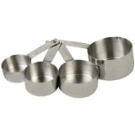
Measuring cups – Look on these cups for the label, usually on the handle. It will tell you how much each holds (1 cup, ½ cup, 1/3 cup or ¼ cup). I like to use colored measuring cups, because you can teach your child colors while teaching him measurements and sizes.
Use these measuring cups for dry ingredients like flour or sugar.

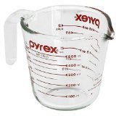
Liquid measuring cup – This measuring cup is for measuring liquids like water or milk. To use this, pour the liquid into the cup.
Lean down so that you can look at the side markings at eye level. The liquid must be EXACTLY on the right line—not above the line or below the line.

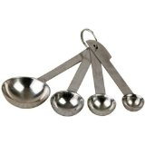
Measuring spoons – Look on each spoon to find how much it holds. Sometimes the measuring spoons are hooked together like the ones in the picture. When you use a measuring spoon, the ingredient should be level with the top of the spoon.

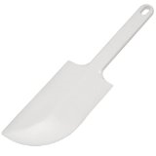
Bowl scraper spatula – Use this to make sure that you get all the ingredients from the bowl.
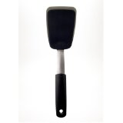
Cookie spatula – This can be confusing, but this is also called a spatula. The cookie spatula is a good tool to remove dog bones or dog cookies from a cookie sheet after they are baked.

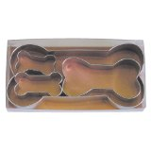
Dog bone cookie cutters – Use bone shaped cookie cutters if you are making dog bones.

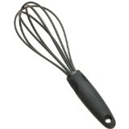
Whisk – This is used to mix ingredients and to whip eggs and liquids.


Wooden spoon – Use a wooden spoon to stir the batter.

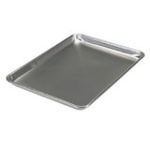
Cookie sheet – This is used to bake dog bones and dog cookies.

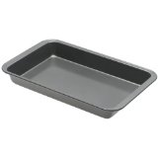
Brownie pan – Use this kind of pan to make dog brownies or dog “bar cookies”.

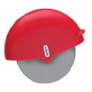
Pizza cutter – Using a pizza cutter is a great way to cut dog biscuits. It’s a lot easier than trying to cut them with a knife. This particular style has a nice hand hold for kids.

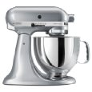
Electric mixer – You can use a mixer for many of the dog treat recipes. Mom or Dad should help you use the mixer. Always turn off the mixer before you put a spoon or spatula into the mixer bowl.

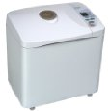
Bread machine – This is the easiest way to mix dough. If your family has a bread machine, you may be able to make the dough by yourself. I have a Panasonic, and I love it!

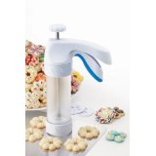
Cookie press – You will need a cookie press if you want to make the cookie press (or spritz) dog cookies. Kuhn Rikon has a good quality press. It’s what I use.

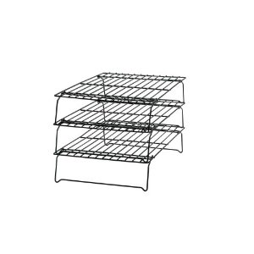
Cookie rack – This is very nice for cooling cookies, but it’s not absolutely necessary. For many years, I just used a clean towel to cool my cookies—and it worked just fine. (The downside is that you end up with a lot of kitchen towels to wash.)
You won’t need everything on this list to bake dog treats. But you will need to make sure that you have everything that you need for the recipe that you are making.

Healthy Dog Treat Ingredients
Cooking for your dog can be lots of fun, but you need to make sure that the food you use is healthy and safe for dogs.
People foods seem safe, but that is not always true. Sometimes people foods are foods toxic to dogs. That means that they can make your dog sick, like poison. So it is very important to make sure that the ingredients in your dog treats are safe.
Here are some safe and healthy foods that you can use:
- Apples or applesauce
- Apricots – add ½ cup chopped dried apricots to a recipe.
- Bananas
- Barley flour
- Blueberries – add ½ cup.
- Carob powder – Never use chocolate or cocoa
- Carob chips – Never use chocolate chips
- Oatmeal
- Oat bran
- Oat flour
- Peanuts – add ½ cup chopped peanuts to a recipe.
- Sunflower seeds – add ½ cup sunflower seeds to a recipe.
- Wheat bran
- Wheat germ
- Whole wheat flour

When you substitute a whole grain flour (or bran or germ) for unbleached white flour, the dough will be a little sticky.

Dog bones and biscuits - You may have to add some extra flour so that you can handle it without getting sticky dough all over your fingers. Add just a little at a time, until the dough is easy to handle and you can roll it out.

Drop cookies and bar cookies – You can just substitute one flour for another, and it won’t make any difference.

Cookie press cookies – These can be a little tricky, so you should probably just follow the recipe without substituting ingredients.

Just for Moms and Dads

This cookbook was written for you and your child—to bake together.
Many parents wonder how old their child should be, when they start to cook together. My answer is—as soon as you’re ready to get started.
Let me explain. While these recipes were all created with children in mind, they can be used by children of different ages.
And, in addition, many children (even some older children) will need supervision or help.
Here’s how to use the e-book:

Preschoolers and Young Children
For very young children: For the most part, you will need to do most of the activities, but, as your child learns more skills, he can do more.
Have your child do the things that he can. For example, you measure the flour and then have your child put it into the bowl. Or let your child cut one or two dog bones that she can claim as her own. Gradually let her cut more and more, as she gains the skill and patience to do so.

Choosing a Recipe
Choose an appropriate recipe: Little hands have not developed advanced fine motor coordination. So start with recipes that will be easy for your child, to ensure success.
For example, making bar cookies or drop cookies is a lot easier for very young children than making cookie press cookies (better for older children), because of the hand coordination required.
And, if you decide to make dog bones together, use a large dog bone cookie cutter with younger children—and make sure there is lots of flour for dipping the cutter, so the cookie cutter doesn’t stick to the dough.

Supervision
Supervision or help: Some kitchen tools will require your supervision or help. Younger children should not use a mixer by themselves, and they should have help cutting biscuits with a sharp pizza cutter.
Older children may be able to work more independently. You’ll need to use your best judgment on these matters.
For all children who are learning to cook—it is important that you stay in the kitchen with them. It only takes a matter of seconds for something to go wrong or for an accident to occur.
Make sure you have all the tools and ingredients that you will need, before you start cooking. Then stay with your child until the project is over.

Measurements
Measuring: To make sure that a dog treat project is successful, you should supervise the measurement of ingredients.

Following Directions
Reading and following directions: Since children are still learning to read well and follow directions, this is another area that you should supervise (or just double check to make sure the directions are being followed).

Timing the Project
Timing: Show your child how to time the baking. Double check to make sure the kitchen timer is set properly.
Help your child set the oven temperature.

Happy Dog Anise Bar Cookies
These Dog Cookies (like all the dog treats in the book) are safe for tasting when baked. (Just in case there’s a taster in the crowd!)
Anise is often used in Italian cookies for people. And the smell and taste of anise can drive dogs wild!
Everyone in your household will love the smell of these dog cookies while they are baking.

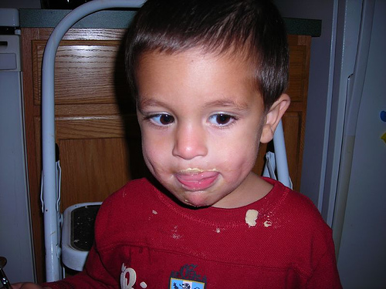
Photo by guy schmidt
Ingredients
- 4 eggs
- ¼ cup brown sugar or raw sugar
- 2 cups whole wheat flour
- 1 tablespoon anise seeds
- ½ teaspoon baking soda

Directions
- Prepare the Batter
- Mix the flour, anise seeds and baking soda in a medium size bowl. Set aside.
- With an electric mixer (or whisk), mix the eggs and sugar. Mix well.
- Add the dry ingredients to the wet ingredients, slowly. (If you add them too fast, the flour will fly up, out of the bowl.) Mix well. You can use the electric mixer or a wooden spoon.

- Prepare the Pan
- Grease a cookie sheet, using shortening or a baking spray vegetable oil.

- Spread the Batter
- Spread the batter thinly (1/4” thick) on the prepared cookie sheet.

- Bake
- Bake at 375 degrees F for 50 minutes. When the cookies are done, let them cool for 15 minutes. Then break them into pieces.

Dry overnight - Turn off the oven and let the anise cookies dry in the warm oven overnight. In the morning, when the cookies are dried, they will be dry and hard.
Storage - Store the cookies in the refrigerator in an airtight container (up to 30 days). For longer storage, keep the cookies in the freezer.

Begging for Bananas Brownies
Most dogs LOVE bananas. If you have a dog who is a banana lover, he will definitely think these brownies are tasty.

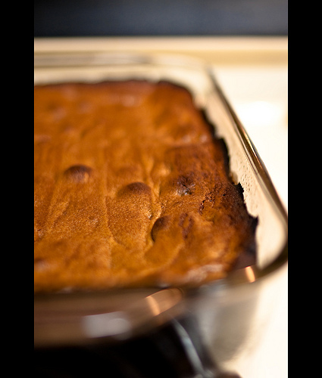
Photo by Robert S. Donovan
Ingredients
- ½ cup butter (left at room temperature for 1 hour, to soften)
- ½ cup brown sugar
- 3 eggs
- 1 ½ cups ripe bananas, mashed
- 1 teaspoon vanilla
- 2 ½ cups all-purpose flour
- 1 teaspoon baking soda
- Unsweetened carob chips (optional)
Directions
- Prepare the Batter
- With an electric mixer (or whisk), beat the butter and sugar until they are well mixed.
- Add the eggs, bananas and vanilla. Mix well.
- Slowly add the flour and baking soda to the wet ingredients. (If you add them too fast, the flour will fly up, out of the bowl.) Mix well.

- Prepare the Cookie Pan
- Grease a 15” x 10” brownie or cake baking pan, using shortening.

- Pour the Batter
- Pour the batter into the prepared pan. Spread the batter with a spatula so that it is even in the pan.
- Optional (means that you can do it, but you don’t have to) – Sprinkle carob chips on top of the batter.

- Bake
- Bake at 350 degrees F for 30 minutes.
Dog brownies can be served soft (like your brownies) or you can dry them in the oven to make them hard, like energy bars.
Dry overnight - To do this, cut the cookies into bars and put them back in the oven (with the oven off, but still warm). In the morning, when the cookies are dried, they will be dry and hard.
Storage - Store the dried dog cookies in the refrigerator in an airtight container (up to 30 days). For longer storage, keep the dog cookies in the freezer.

Pretend Chocolate Brownies
You probably already know that chocolate is VERY BAD for dogs. But did you know that carob looks, smells, and tastes ALMOST like chocolate?
And, the best part is that carob is GOOD for your dog. Veterinarians (dog doctors) recommend carob for dogs (and other animals, like farm animals) to keep them healthy.
These carob brownies are healthy for your dog—and they are easy, too!

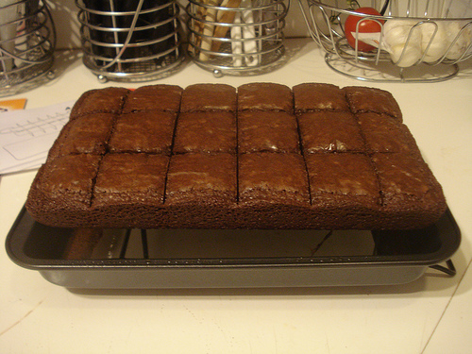
Photo by Justjoolie
Ingredients
- 1 cup vegetable oil
- ¼ cup brown sugar
- 5 eggs
- 1 teaspoon vanilla
- 1 ¾ cups unbleached white flour (or whole wheat flour)
- ½ cup carob powder
- ½ cup carob chips (optional)
Directions
- Prepare the Batter
- With an electric mixer, combine the oil and sugar until they are well mixed. Add the eggs and vanilla. Mix well.
- Slowly add the flour and carob powder to the wet ingredients. (If you add them too fast, the flour will fly up, out of the bowl.) Mix well.

- Prepare the Cookie Pan
- Grease a 9” x 13” baking pan, using shortening.

- Pour the Batter
- Pour the batter into the prepared pan. Spread the batter with a spatula so that it is even in the pan.
- Optional (means that you can do it, but you don’t have to) – Sprinkle carob chips on top of the batter.

- Bake
- Bake at 350 degrees F for 30 minutes.

Dog brownies can be served soft (like your brownies) or you can dry them in the oven to make them hard, like energy bars.

Dry overnight - To do this, cut the cookies into bars and put them back in the oven (with the oven off, but still warm). In the morning, when the cookies are dried, they will be dry and hard.
Storage - Store the dried dog cookies in the refrigerator in an airtight container (up to 30 days). For longer storage, keep the dog cookies in the freezer.

Doggie Energy Bars

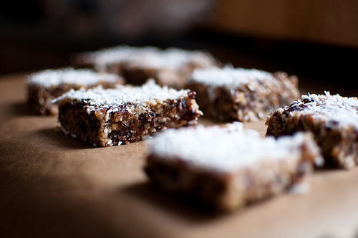
Photo by humbert15
Ingredients
- ¾ cup shortening
- 1 teaspoon vanilla
- 2 eggs
- 1 cup whole wheat flour
- 2 cups oatmeal, quick or old fashioned – either will work
- ¾ teaspoon baking soda
- 1/2 teaspoon salt
- 1 teaspoon cinnamon
- ¼ teaspoon ginger
- 1 cup peanuts, chopped
Directions
- Prepare the Dough
- With an electric mixer, cream the shortening. Add the eggs and vanilla. Mix well.
- Mix the dry ingredients in another bowl and then add them to the wet ingredients. (If you add them too fast, the flour will fly up, out of the bowl.) Mix well.

- Prepare the Mini Muffin Pan
- Lightly grease a mini muffin pan, using shortening or a vegetable oil baking spray.

- Fill the Muffin Cups
- Using 2 tablespoons (tableware, used for eating), spoon a tablespoon full of dough into each mini muffin cup.

- Bake
- Bake at 350 degrees F for 15-20 minutes, or until lightly browned.

Dry overnight - Turn off the oven and let the energy bars dry in the warm oven overnight. In the morning, when the bars are dried, they will be dry and hard.
Storage - Store the dried energy bars in the refrigerator in an airtight container (up to 30 days). For longer storage, keep the energy bars in the freezer.

Happy Tummy Gingerbread
Do you like to smell gingerbread baking in the oven? So does your dog.
These gingerbread bar cookies have healthy molasses and ginger in them. Ginger will help keep your dog’s tummy and digestive system working well.

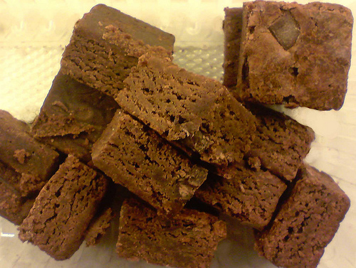
Photo by morebyless
Ingredients
- 1 cup whole wheat flour
- 1 tablespoon ginger
- 1 teaspoon cinnamon
- 1 teaspoon baking soda
- ¼ cup brown sugar or raw sugar
- ½ cup butter or margarine (1 stick)
- 3 eggs
- ¼ cup milk
- 2 tablespoons molasses

Directions
- Prepare the Batter
- Mix the dry ingredients (except sugar) in a medium size bowl. Set aside.
- With an electric mixer, cream the butter or margarine and sugar together. Add the milk, eggs, and molasses. Mix well.
- Add the dry ingredients to the wet ingredients, slowly. (If you add them too fast, the flour will fly up, out of the bowl.) Mix well.

- Prepare the Pan
- Grease a 10”x 7”x 2 ½” pan, using shortening or a baking spray vegetable oil.

- Fill the Pans
- Spread the batter in the prepared pan.

- Bake
- Bake at 375 degrees F for 50 minutes.

Gingerbread can be served soft or you can dry it in the oven to harden the pieces, (like energy bars or gingerbread cookies).

Dry overnight - Turn off the oven and let the gingerbread dry in the warm oven overnight. In the morning, when the gingerbread is dried, the pieces will be dry and hard.
Storage - Store the gingerbread in the refrigerator in an airtight container (up to 30 days). For longer storage, keep the cookies in the freezer.

Yummy Peanut Butter Brownies
Dogs like these peanut butter bar cookies just the way they are. But, if your dog REALLY likes peanuts and peanut butter, you can add ½ cup of chopped peanuts—for an extra special treat!

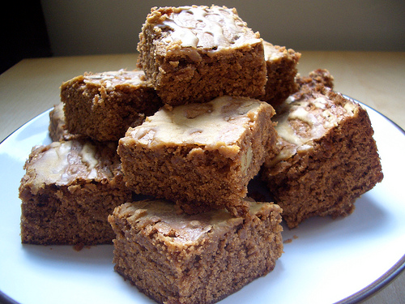
Photo by imcountingfoz
Ingredients
- ½ cup butter or margarine
- 1/3 cup peanut butter
- ¼ cup brown sugar or raw sugar
- 1 egg
- ½ teaspoon vanilla
- 1 cup oatmeal
- 1 cup whole wheat flour
- 2 teaspoons cinnamon
- ½ teaspoon baking soda

Directions
- Prepare the Batter
- With an electric mixer, combine the butter or margarine, sugar, peanut butter, vanilla and egg together, until they are well mixed.
- Mix the dry ingredients in another bowl and then add them to the wet ingredients, slowly. (If you add them too fast, the flour will fly up, out of the bowl.) Mix well.

- Prepare the Pan
- Grease a 9” x 13” pan, using shortening or a baking spray vegetable oil.

- Fill the Pans
- Spread the batter in the prepared 9” x 13” pan.

- Bake
- Bake at 350 degrees F for 25-30 minutes.

These bar cookies can be served soft or dried in the oven to harden them.

Dry overnight - Turn off the oven and let the bar cookies dry in the warm oven overnight. In the morning, when the bars are dried, they will be dry and hard.
Storage - Store the dried bar cookies in the refrigerator in an airtight container (up to 30 days). For longer storage, keep the cookies in the freezer.

Slim Jim Pumpkin Brownies
Did you know that pumpkin is very healthy for your dog?
Veterinarians (dog doctors) give dogs pumpkin when they have sick stomachs. And if your dog is fat, pumpkin can help her lose weight.
And pumpkin has lots of healthy vitamins, as well.

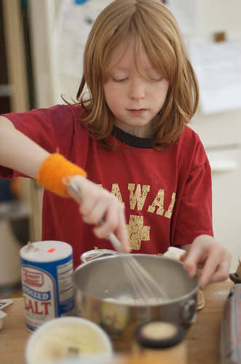
Photo by qwrrty
Ingredients
- 1 cup vegetable oil
- ¼ cup brown sugar or raw sugar
- 2 cups canned pumpkin
- 4 eggs
- 2 cups whole wheat flour
- 2 teaspoons cinnamon
- 2 teaspoons baking powder
- 1 teaspoon baking soda
- ¼ teaspoon salt
Directions
- Prepare the Batter
- With an electric mixer, combine the oil, sugar, pumpkin and eggs together, until they are well mixed.
- Mix the dry ingredients in another bowl and then add them to the wet ingredients, slowly. (If you add them too fast, the flour will fly up, out of the bowl.) Mix well.

- Fill the Pans
- Spread the batter in 2 ungreased 9” x 13” pans.

- Bake
- Bake at 350 degrees F for 25-30 minutes.

For a special treat, spread the brownies with a little cream cheese, before serving to your dog.
If your dog is fat, cut the pieces very small. Pumpkin can help your dog lose weight, but you still have to make sure she doesn’t get TOO MUCH food to eat.
These bar cookies can be served soft or dried in the oven to harden them.

Dry overnight - Turn off the oven and let the bar cookies dry in the warm oven overnight. In the morning, when the bars are dried, they will be dry and hard.
Storage - Store the dried brownies in the refrigerator in an airtight container (up to 30 days). For longer storage, keep the cookies in the freezer.

Good Boy Banana Biscuits
Most dogs love bananas. Make banana biscuits for your dog, and he’ll be your best friend forever!

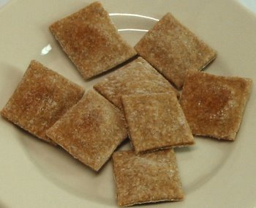
Good Boy Banana Biscuits
Ingredients
- 3 cups unbleached flour
- 1 ½ teaspoons dry yeast
- ¼ cup oat bran (or wheat bran)
- 1 tablespoon sugar
- ½ cup mashed ripe bananas (1 banana)
- 1 teaspoon vanilla extract
- ¾ cup water
- ¼ cup vegetable oil

Directions
- Mix the Dough
- Mix the dough with your electric mixer and a dough hook…or place all ingredients in your bread machine on the dough cycle. (If you use a mixer, do this slowly, so the flour doesn’t fly out of the bowl.)
- When the dough is mixed (electric mixer) or finished (bread machine), divide it into 3 portions.

- Prepare the cookie sheet
- Spray a couple of cookie sheets lightly with cooking oil spray.

- Cut out the biscuits
- Sprinkle about ¼ cup of flour on a large cutting board.
- Using a rolling pin, roll the dough until it is about ¼” thick.
- Turn the dough to make sure that both sides have enough flour to roll easily.
- Cut squares to make the dog biscuits, using a pizza cutter. Place the biscuits on the cookie sheets. (You can use a cookie spatula or a cookie shovel to do this.)

- Let the dog biscuits rise
- Cover the dog biscuits (with a clean dish towel) and let them sit in a warm place for 1 hour. (In the winter, heat the oven to 175 degrees for 5 minutes. Then turn it off.)
- You can now place the dog biscuits in the warm oven (turned off) to rise--for 1 hour.

- Bake the biscuits
- Bake at 275 degrees F for 60 minutes, until the dog biscuits are a light, golden brown. (You may have to turn them once while they are baking—to brown the other side.)

Dry overnight - Turn off the oven and let the dog biscuits sit in the oven overnight. This will complete the drying process. When done, they will be dry and very hard.

Storage - Store the dog biscuits in a cool, dry place with a tight cover (up to 30 days). For longer storage, keep the dog biscuits in the refrigerator or freezer.

Bacon and Cheese Biscuits
Bacon and cheese taste really good together. And I think your dog will agree. This recipe uses cheese and bacon bits—the kind that you use on your salad.
Here’s a little secret…I tasted these cheese biscuits the last time I made them for Skipper, my dog. They are REALLY good! They taste like cheese crackers from the store—only better!
Maybe your dog would share a couple with you…

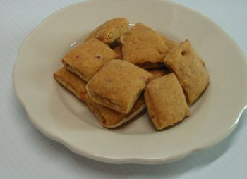
Bacon and Cheese Biscuits
Ingredients
- 1 cup water
- ¼ cup vegetable oil
- 1 ½ cups whole wheat flour
- 1 ½ cups unbleached white flour
- 1 ½ teaspoons dry yeast
- 3 tablespoons parmesan cheese or cheddar cheese powder
- 2 tablespoons bacon bits

Directions
- Prepare the cookie sheet
- Spray a couple of cookie sheets lightly with cooking oil spray.

- Mix the Dough – Use a mixer or a bread machine.
- Mixer - Mix the dry ingredients in a large bowl. (Use a dough hook on the mixer.) Add the water and oil, and mix until you have a nice dough.
- Bread machine Place all ingredients in your bread machine on the dough cycle. Remove when the dough is finished and the bread machine beeps.

- Cut out the biscuits
- Divide the dough into 3 portions.
- Sprinkle about ¼ cup of flour on a large cutting board.
- Using a rolling pin, roll the dough until it is about ¼” thick.
- Turn the dough to make sure that both sides have enough flour to roll easily.
- Cut the dog biscuits into squares, with a pizza cutter. You will have leftover pieces of dough. Just put them together and roll them into a ¼” sheet to make more biscuits.
- Place the biscuits on the cookie sheets. (You can use a cookie spatula or a cookie shovel to do this.)

- Let the dog biscuits rise in a warm place.
- Cover the dog biscuits (with a clean dish towel) and let them sit in a warm place for 1 hour.
- In the winter, heat the oven to 175 degrees for 5 minutes. Then turn it off. You can now place the dog biscuits in the warm oven to rise, for 1 hour.

- Bake the biscuits.
- Bake at 275 degrees F for 60 minutes, until the dog biscuits are a light, golden brown. (You may have to turn them once while they are baking—to brown the other side.)

Dry overnight - Turn off the oven and let the dog biscuits sit in the oven overnight. This will complete the drying process. When done, they will be dry and very hard.
Storage - Store the dog biscuits in a cool, dry place with a tight cover (up to 30 days). For longer storage, keep the dog biscuits in the refrigerator or freezer.

Peanut Butter Dog Biscuits
Did you know that dogs love peanut butter—just as much as you do? Here’s a dog biscuit recipe that your dog will love.
Maybe both of you can sneak a little taste of the peanut butter while you are making the biscuits…

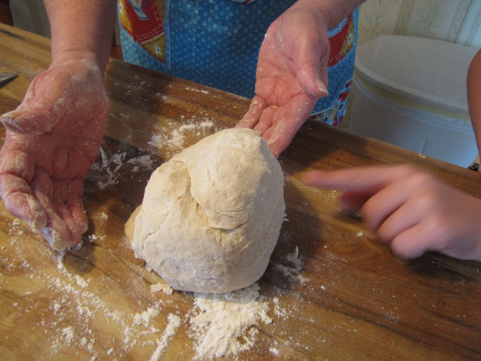

Ingredients
- 2 cups whole wheat flour
- 2 ½ cups unbleached flour
- ¼ cup wheat germ or wheat bran
- 1 ½ teaspoons dry yeast
- ½ cup peanut butter
- 1 ½ cups water

Directions
- Prepare the cookie sheet
- Spray a couple of cookie sheets lightly with cooking oil spray.

- Mix the Dough – Use a mixer or a bread machine.
- Mixer - Mix the dry ingredients in a large bowl. (Use a dough hook on the mixer.) Add the water, and peanut butter, and mix until you have a nice dough.
- Bread machine Place all ingredients in your bread machine on the dough cycle. Remove when the dough is finished and the bread machine beeps.

- Cut out the biscuits
- Divide the dough into 3 portions.
- Sprinkle about ¼ cup of flour on a large cutting board.
- Using a rolling pin, roll the dough until it is about ¼” thick.
- Turn the dough to make sure that both sides have enough flour to roll easily.
- Cut out the dog biscuits with a pizza cutter. You will have leftover pieces of dough. Just put them together and roll them into a ¼” sheet to make more biscuits.
- Place the biscuits on the cookie sheets. (You can use a cookie spatula or a cookie shovel to do this.)

- Let the dog biscuits rise in a warm place.
- Cover the dog biscuits (with a clean dish towel) and let them sit in a warm place for 1 hour.
- In the winter, heat the oven to 175 degrees for 5 minutes. Then turn it off. You can now place the dog biscuits in the warm oven to rise, for 1 hour.

- Bake the biscuits.
- Bake at 275 degrees F for 60 minutes, until the dog biscuits are a light, golden brown. (You may have to turn them once while they are baking—to brown the other side.)

Dry overnight - Turn off the oven and let the dog biscuits sit in the oven overnight. This will complete the drying process. When done, they will be dry and very hard.
Storage - Store the dog biscuits in a cool, dry place with a tight cover (up to 30 days). For longer storage, keep the dog biscuits in the refrigerator or freezer.

Biscuits for Dogs with Allergies
Most dogs are naturally healthy and can eat almost anything safe for dogs. But, there are a few dogs who are born with dog food allergies.
If your dog has food allergies, you will have to be careful when you bake treats for him.
Make sure you understand what foods your dog cannot eat, and check the list of ingredients in the recipe, before you start baking.

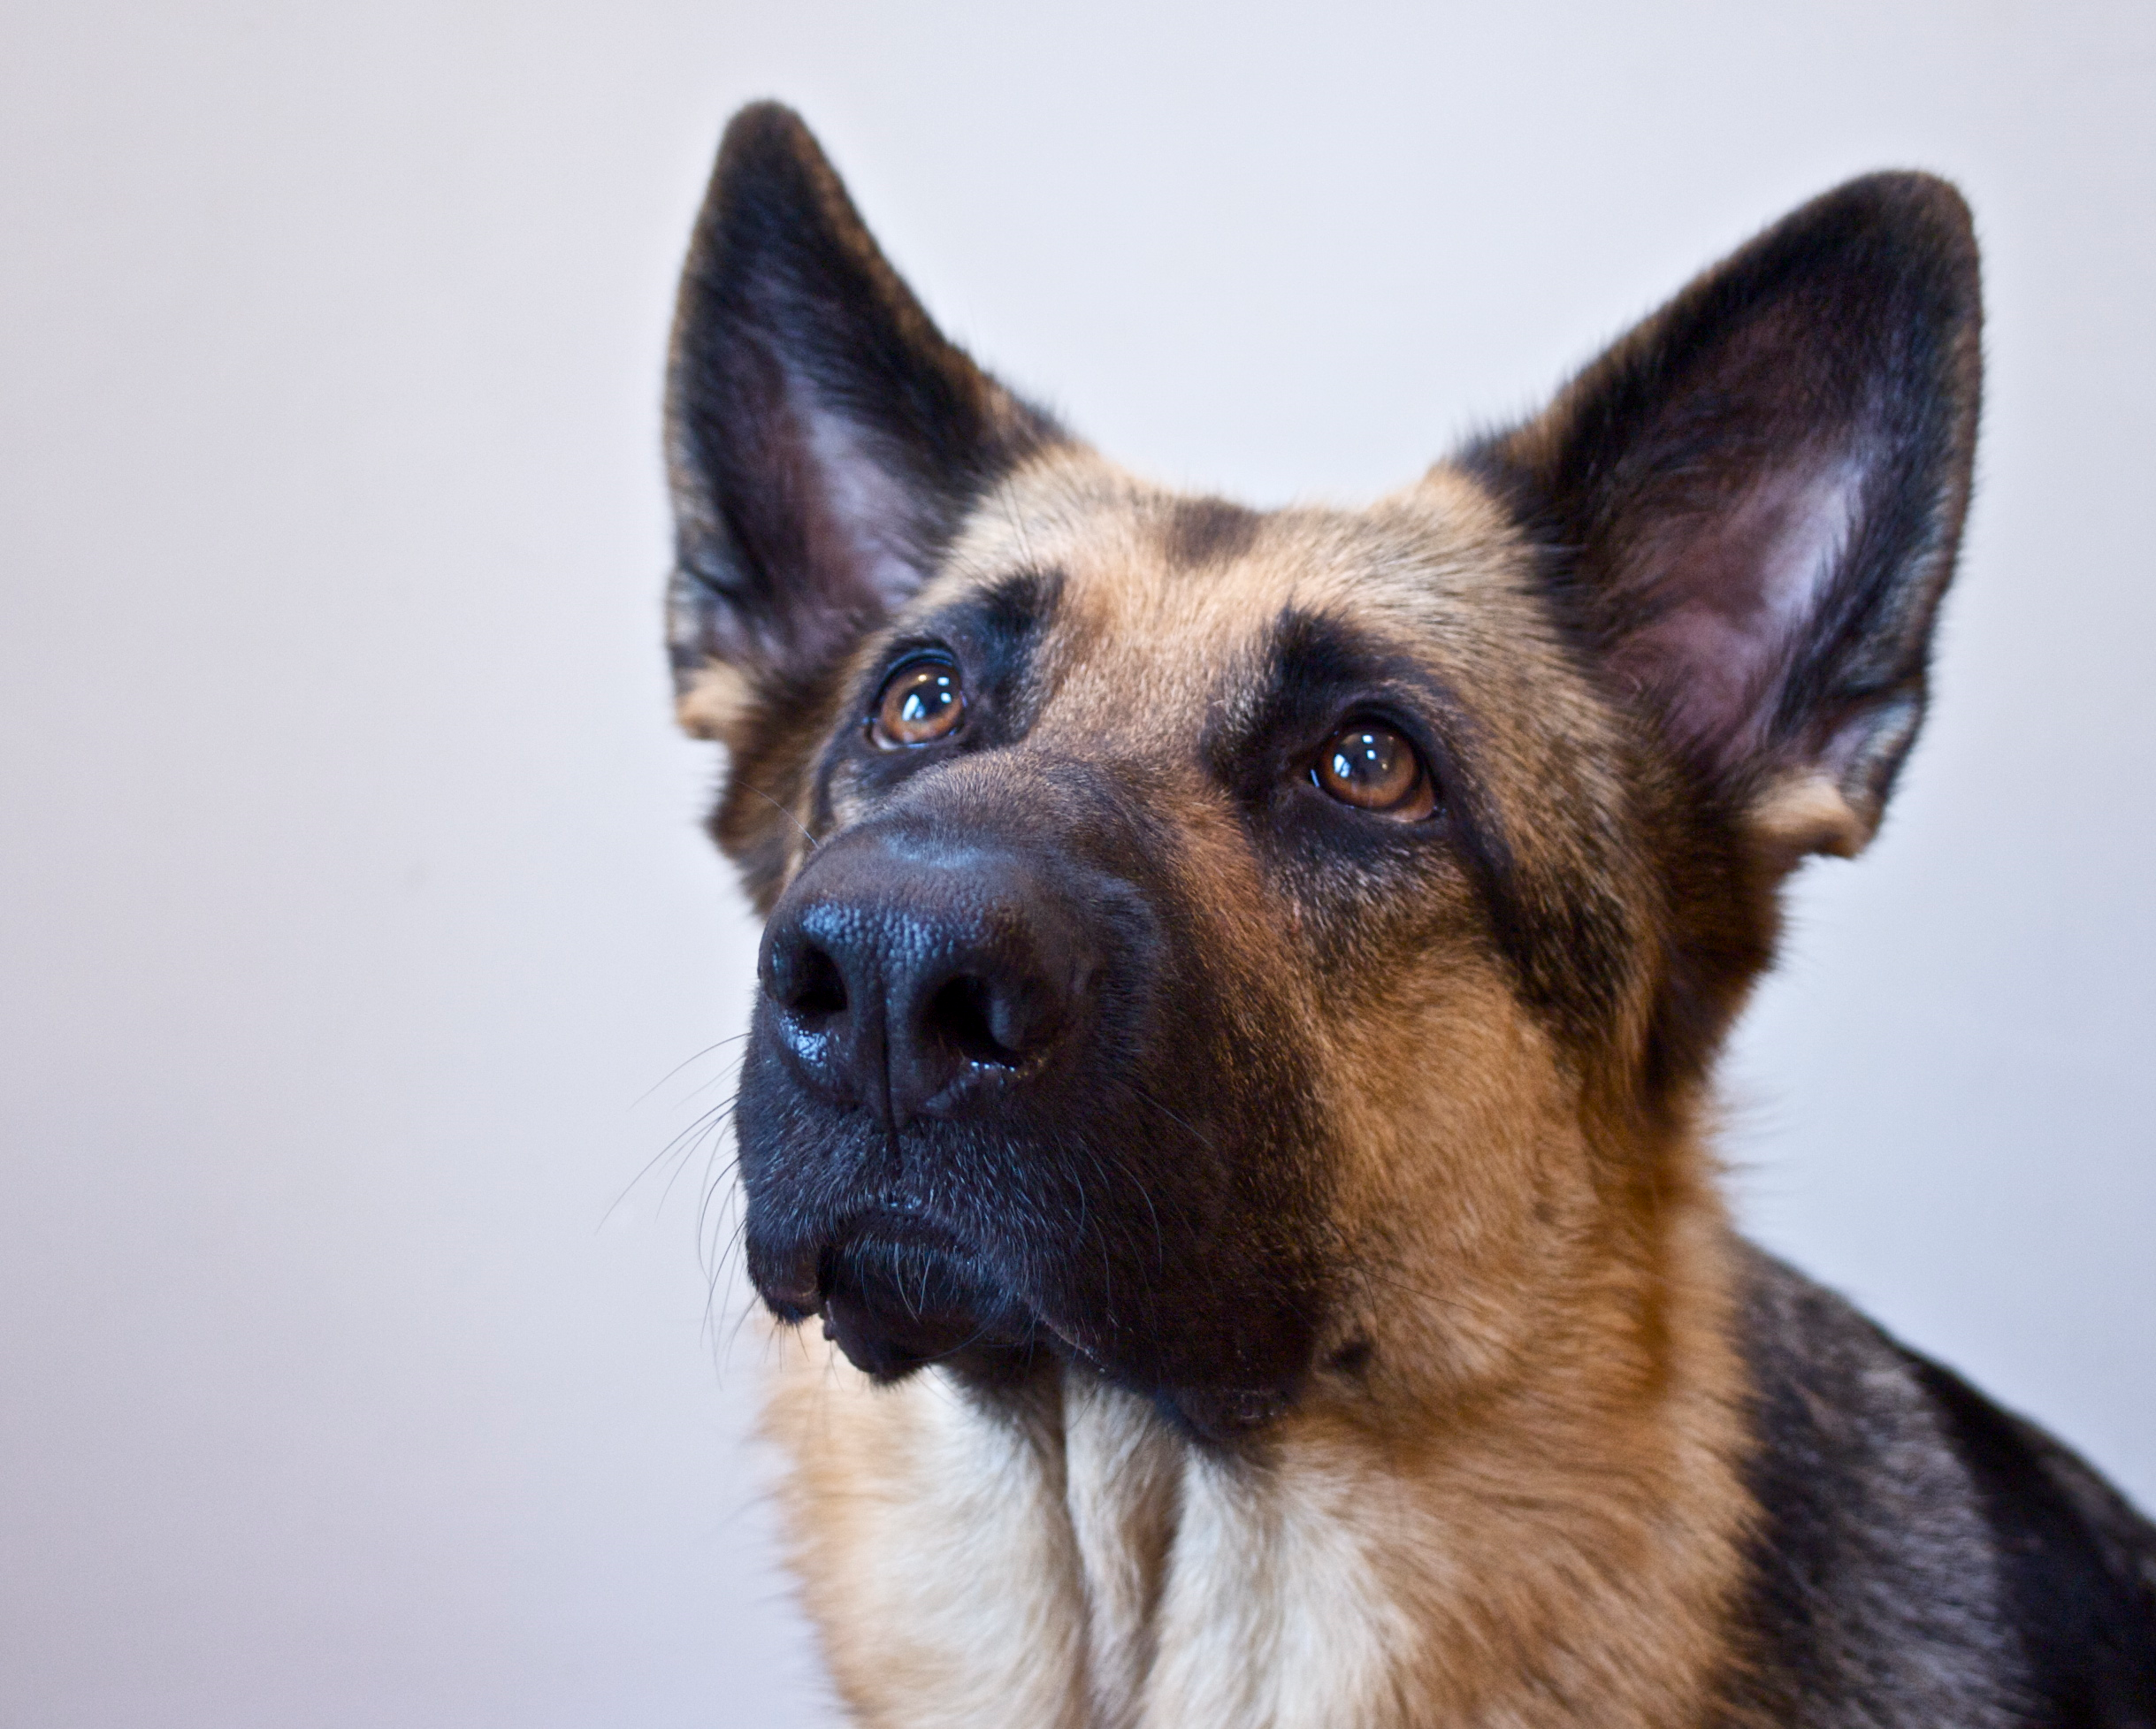
German Shepherds are the dog breed most likely to have dog food allergies.
Ingredients
- 1 ½ cups buckwheat flour
- 1 ½ cups rice flour
- ¼ cup soy flour
- 1 teaspoon cinnamon
- 1 teaspoon baking powder
- ¼ cup vegetable oil
- 1 cup water
Directions
- Prepare the cookie sheet
- Spray a couple of cookie sheets lightly with cooking oil spray.

- Mix the Dough – Use a mixer or a bread machine.
- Mixer - Mix the dry ingredients in a large bowl. (Use a dough hook on the mixer.) Add the water and oil, and mix until you have a nice dough.
- Bread machine Place all ingredients in your bread machine on the dough cycle. Remove when the dough is finished and the bread machine beeps.

- Cut out the biscuits
- Divide the dough into 3 portions.
- Sprinkle about ¼ cup of flour on a large cutting board.
- Using a rolling pin, roll the dough until it is about ¼” thick.
- Turn the dough to make sure that both sides have enough flour to roll easily.
- Cut out the dog biscuits with a pizza cutter. You will have leftover pieces of dough. Just put them together and roll them into a ¼” sheet to make more biscuits.
- Place the biscuits on the cookie sheets. (You can use a cookie spatula or a cookie shovel to do this.)

- Let the dog biscuits rise in a warm place.
- Cover the dog biscuits (with a clean dish towel) and let them sit in a warm place for 1 hour.
- In the winter, heat the oven to 175 degrees for 5 minutes. Then turn it off. You can now place the dog biscuits in the warm oven to rise, for 1 hour.

- Bake the biscuits.
- Bake at 275 degrees F for 60 minutes, until the dog biscuits are a light, golden brown. (You may have to turn them once while they are baking—to brown the other side.)

Dry overnight - Turn off the oven and let the dog biscuits sit in the oven overnight. This will complete the drying process. When done, they will be dry and very hard.
Storage - Store the dog biscuits in a cool, dry place with a tight cover (up to 30 days). For longer storage, keep the dog biscuits in the refrigerator or freezer.

Pumpkin Eater Dog Biscuits
Pumpkin is good for dogs. Veterinarians use pumpkin for dogs who have stomach troubles and have trouble digesting their food.
Pumpkin also helps fat dogs lose weight. And it has lots of vitamin A in it.
But the best thing about using pumpkin in dog treats is that dogs love it!



Ingredients
- 1 ½ cups whole wheat flour
- 1 ½ cups unbleached white flour
- ¼ cup wheat germ
- 1 teaspoon cinnamon
- 1 ½ teaspoons dry yeast
- ¼ cup vegetable oil
- ½ cup canned pumpkin
- 3/4 cup water
Directions
- Prepare the cookie sheet
- Spray a couple of cookie sheets lightly with cooking oil spray.

- Mix the Dough – Use a mixer or a bread machine.
- Mixer - Mix the dry ingredients in a large bowl. (Use a dough hook on the mixer.) Add the water, pumpkin and oil, and mix until you have a nice dough.
- Bread machine Place all ingredients in your bread machine on the dough cycle. Remove when the dough is finished and the bread machine beeps.

- Cut out the biscuits
- Divide the dough into 3 portions.
- Sprinkle about ¼ cup of flour on a large cutting board.
- Using a rolling pin, roll the dough until it is about ¼” thick.
- Turn the dough to make sure that both sides have enough flour to roll easily.
- Cut out the dog biscuits with a pizza cutter.
- You will have leftover pieces of dough. Just put them together and roll them into a ¼” sheet to make more biscuits.
- Place the biscuits on the cookie sheets. (You can use a cookie spatula or a cookie shovel to do this.)

- Let the dog biscuits rise in a warm place.
- Cover the dog biscuits (with a clean dish towel) and let them sit in a warm place for 1 hour.
- In the winter, heat the oven to 175 degrees for 5 minutes. Then turn it off. You can now place the dog biscuits in the warm oven to rise, for 1 hour.

- Bake the biscuits.
- Bake at 275 degrees F for 60 minutes, until the dog biscuits are a light, golden brown. (You may have to turn them once while they are baking—to brown the other side.)

Dry overnight - Turn off the oven and let the dog biscuits sit in the oven overnight. This will complete the drying process. When done, they will be dry and very hard.
Storage - Store the dog biscuits in a cool, dry place with a tight cover (up to 30 days). For longer storage, keep the dog biscuits in the refrigerator or freezer.

Pretend Chocolate (Carob) Biscuits
Real chocolate can make dogs very, very sick. But, that doesn’t mean that your dog can’t have biscuits that taste almost like chocolate.
You can make them from carob—which is very good for your dog!
I think that you will like the smell of these biscuits baking in the oven, too.

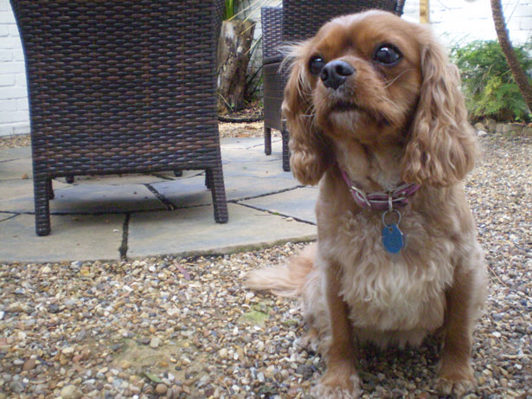

Ingredients
- 1 ½ cups whole wheat flour
- 1 ½ cups unbleached white flour
- ¼ cup carob powder
- ¼ cup wheat germ
- 1 ½ teaspoons dry yeast
- ¼ cup vegetable oil
- 1 cup water
Directions
- Prepare the cookie sheet
- Spray a couple of cookie sheets lightly with cooking oil spray.

- Mix the Dough – Use a mixer or a bread machine.
- Mixer - Mix the dry ingredients in a large bowl. (Use a dough hook on the mixer.) Add the water and oil, and mix until you have a nice dough.
- Bread machine Place all ingredients in your bread machine on the dough cycle. Remove when the dough is finished and the bread machine beeps.

- Cut out the biscuits
- Divide the dough into 3 portions.
- Sprinkle about ¼ cup of flour on a large cutting board.
- Using a rolling pin, roll the dough until it is about ¼” thick.
- Turn the dough to make sure that both sides have enough flour to roll easily.
- Cut out the dog biscuits with a pizza cutter. You will have leftover pieces of dough. Just put them together and roll them into a ¼” sheet to make more biscuits.
- Place the biscuits on the cookie sheets. (You can use a cookie spatula or a cookie shovel to do this.)

- Let the dog biscuits rise in a warm place.
- Cover the dog biscuits (with a clean dish towel) and let them sit in a warm place for 1 hour.
- In the winter, heat the oven to 175 degrees for 5 minutes. Then turn it off. You can now place the dog biscuits in the warm oven to rise, for 1 hour.
- Bake the biscuits.
- Bake at 275 degrees F for 60 minutes, until the dog biscuits are a light, golden brown. (You may have to turn them once while they are baking—to brown the other side.)

Dry overnight - Turn off the oven and let the dog biscuits sit in the oven overnight. This will complete the drying process. When done, they will be dry and very hard.
Storage - Store the dog biscuits in a cool, dry place with a tight cover (up to 30 days). For longer storage, keep the dog biscuits in the refrigerator or freezer.

Heavenly Anise Dog Bones
Anise seeds smell and taste like licorice.
Many people like the taste of anise seeds, and so do dogs. If you make dog treats with anise seeds, don’t be surprised if your dog sits near the oven—waiting for a treat!

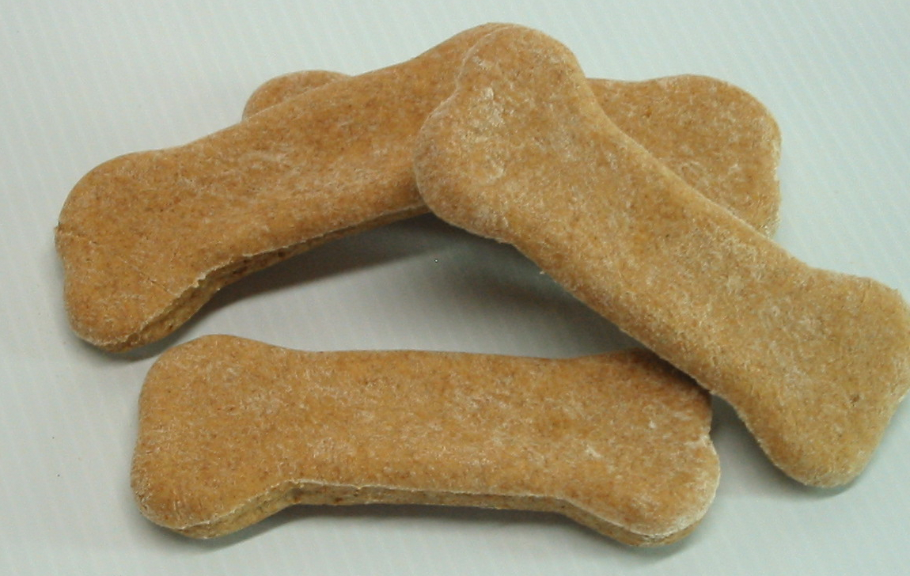

Ingredients
- 1 cup water
- ¼ cup vegetable oil
- 1 ½ cups whole wheat flour
- 1 ½ cups unbleached flour
- 1 ½ teaspoons dry yeast
- 1 tablespoon sugar
- ¼ cup wheat germ
- 1 tablespoon anise seeds
Directions
- Prepare the cookie sheet
- Spray a couple of cookie sheets lightly with cooking oil spray.

- Mix the Dough – Use a mixer or a bread machine.
- Mixer - Mix the dry ingredients in a large bowl. (Use a dough hook on the mixer.) Add the water and oil, and mix until you have a nice dough.
- Bread machine Place all ingredients in your bread machine on the dough cycle. Remove when the dough is finished and the bread machine beeps.

- Cut out the bones
- Divide the dough into 3 portions.
- Sprinkle about ¼ cup of flour on a large cutting board.
- Using a rolling pin, roll the dough until it is about ¼” thick.
- Turn the dough to make sure that both sides have enough flour to roll easily.
- Cut out the dog bones with a dog bone cookie cutter. (Dip the cookie cutter into a bowl of flour between cuts.) You will have leftover pieces of dough. Just put them together and roll them into a ¼” sheet to make more bones.
- Place the bones on the cookie sheets. (You can use a thin metal spatula to do this.)

- Let the dog bones rise in a warm place.
- Cover the dog bones (with a clean dish towel) and let them sit in a warm place for 1 hour.
- In the winter, heat the oven to 175 degrees for 5 minutes, then turn it off. You can now place the dog bones in the warm oven to rise, for 1 hour.
- Bake the bones.
- Bake at 275 degrees F for 60 minutes, until the dog bones are a light, golden brown. (You may have to turn them once while they are baking—to brown the other side.)

Dry overnight - Turn off the oven and let the dog bones sit in the oven overnight. This will complete the drying process. When done, they will be dry and very hard.
Storage - Store the dog bones in a cool, dry place with a tight cover (up to 30 days). For longer storage, keep the dog bones in the refrigerator or freezer.

Apple Spice Dog Bones
Apples and cinnamon are both good for your dog. These yummy dog bones smell like an apple pie when they are in the oven baking.
Dogs have a very good sense of smell—better than yours.

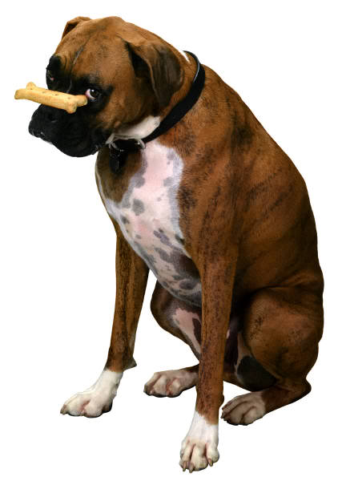

Apple Spice Dog Bones are a favorite of one of our dog friends, Annie.
Sometimes we send her some dog bones, in the mail, for a special occasion. Annie always knows that the box is for her, and she gets really excited.
Do you think she can smell the dog bones through the box?

Ingredients
- 1 ½ cups whole wheat flour
- 1 ½ cups unbleached white flour
- 1/3 cup oats
- 1 teaspoon cinnamon
- 1 ½ teaspoons dry yeast
- 2 tablespoons milk
- 2 tablespoons vegetable oil
- 1/3 cup applesauce
- 1/2 cup water
Directions
- Prepare the cookie sheet
- Spray a couple of cookie sheets lightly with cooking oil spray.

- Mix the Dough – Use a mixer or a bread machine.
- Mixer - Mix the dry ingredients in a large bowl. (Use a dough hook on the mixer.) Add the milk, applesauce, water and oil and mix, until you have a nice dough.
- Bread machine Place all ingredients in your bread machine on the dough cycle. Remove when the dough is finished and the bread machine beeps.

- Cut out the bones
- Divide the dough into 3 portions.
- Sprinkle about ¼ cup of flour on a large cutting board.
- Using a rolling pin, roll the dough until it is about ¼” thick.
- Turn the dough to make sure that both sides have enough flour to roll easily.
- Cut out the dog bones with a dog bone cookie cutter. (Dip the cookie cutter into a bowl of flour between cuts.) You will have leftover pieces of dough. Just put them together and roll them into a ¼” sheet to make more bones.
- Place the bones on the cookie sheets. (You can use a thin metal spatula to do this.)

- Let the dog bones rise in a warm place.
- Cover the dog bones (with a clean dish towel) and let them sit in a warm place for 1 hour.
- In the winter, heat the oven to 175 degrees for 5 minutes, then turn it off. You can now place the dog bones in the warm oven to rise, for 1 hour.

- Bake the bones.
- Bake at 275 degrees F for 60 minutes, until the dog bones are a light, golden brown. (You may have to turn them once while they are baking—to brown the other side.)

Dry overnight - Turn off the oven and let the dog bones sit in the oven overnight. This will complete the drying process. When done, they will be dry and very hard.
Storage - Store the dog bones in a cool, dry place with a tight cover (up to 30 days). For longer storage, keep the dog bones in the refrigerator or freezer.

Banana Dog Bones
Banana Dog Bones are a favorite for many dogs. Most dogs really like the taste of bananas.
And dog bones make great gifts for dog birthdays, Halloween and Christmas.
Did you know that you can use your dog bone recipes to make other shapes, too?

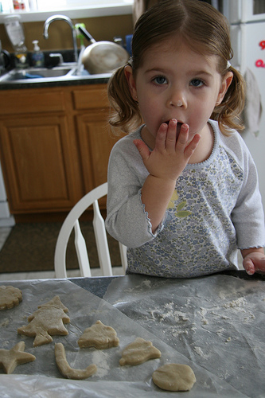
Photo by omniNate

This girl is making stars and Christmas trees for a special Christmas surprise for her dog. She is using the Banana Dog Bones recipe, but she is using cookie cutter shapes with Christmas designs.

Ingredients
- 3 cups unbleached flour
- ¼ cup oat bran (or wheat or rice bran)
- 1 ½ teaspoons dry yeast
- 1 tablespoon sugar
- 1 teaspoon cinnamon
- ½ cup mashed ripe bananas (1 banana)
- ½ teaspoon vanilla extract
- ¾ cup water
- ¼ cup vegetable oil
Directions
- Prepare the cookie sheet
- Spray a couple of cookie sheets lightly with cooking oil spray.

- Mix the Dough – Use a mixer or a bread machine.
- Mixer - Mix the dry ingredients in a large bowl. (Use a dough hook on the mixer.) Add the bananas, vanilla, water and oil and mix until you have a nice dough.
- Bread machine - Place all ingredients in your bread machine on the dough cycle. Remove when the dough is finished and the bread machine beeps.

- Cut out the bones
- Divide the dough into 3 portions.
- Sprinkle about ¼ cup of flour on a large cutting board.
- Using a rolling pin, roll the dough until it is about ¼” thick.
- Turn the dough to make sure that both sides have enough flour to roll easily.
- Cut out the dog bones with a dog bone cookie cutter. (Dip the cookie cutter into a bowl of flour between cuts.) You will have leftover pieces of dough. Just put them together and roll them into a ¼” sheet to make more bones.
- Place the bones on the cookie sheets. (You can use a thin metal spatula to do this.)

- Let the dog bones rise in a warm place.
- Cover the dog bones (with a clean dish towel) and let them sit in a warm place for 1 hour.
- In the winter, heat the oven to 175 degrees for 5 minutes, then turn it off. You can now place the dog bones in the warm oven to rise, for 1 hour.

- Bake the bones.
- Bake at 275 degrees F for 60 minutes, until the dog bones are a light, golden brown. (You may have to turn them once while they are baking—to brown the other side.)

Dry overnight - Turn off the oven and let the dog bones sit in the oven overnight. This will complete the drying process. When done, they will be dry and very hard.

Storage - Store the dog bones in a cool, dry place with a tight cover (up to 30 days). For longer storage, keep the dog bones in the refrigerator or freezer.

Where’s the Beef Dog Bones
These dog bones taste like beef, but the recipe uses beef broth instead of meat. Your dog will like the meaty taste, and the whole wheat flour is good for her.

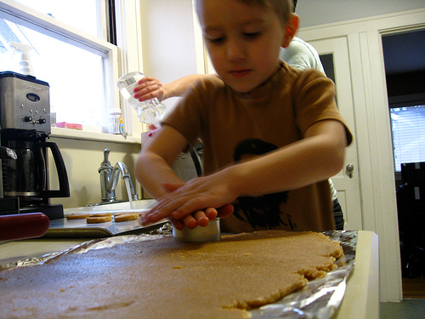
Photo by eyeliam
If you don’t have a cutting board for rolling the dough, you can use aluminum foil, like this boy is doing, in the picture.
Ingredients
- 1 cup beef broth (or 1 cup water and 1 beef bouillon cube)
- ¼ cup olive oil (or vegetable oil)
- 3 cups unbleached white flour
- 1 ½ teaspoons dry yeast
- 2 tablespoons bran (wheat or oat bran)
Directions
- Prepare the cookie sheet
- Spray a couple of cookie sheets lightly with cooking oil spray.

- Mix the Dough – Use a mixer or a bread machine.
- Mixer - Mix the dry ingredients in a large bowl. (Use a dough hook on the mixer.) Add the beef broth and oil and mix until you have a nice dough.
- Bread machine Place all ingredients in your bread machine on the dough cycle. Remove when the dough is finished and the bread machine beeps.

- Cut out the bones
- Divide the dough into 3 portions.
- Sprinkle about ¼ cup of flour on a large cutting board.
- Using a rolling pin, roll the dough until it is about ¼” thick.
- Turn the dough to make sure that both sides have enough flour to roll easily.
- Cut out the dog bones with a dog bone cookie cutter. (Dip the cookie cutter into a bowl of flour between cuts.) You will have leftover pieces of dough. Just put them together and roll them into a ¼” sheet to make more bones.
- Place the bones on the cookie sheets. (You can use a thin metal spatula to do this.)

- Let the dog bones rise in a warm place.
- Cover the dog bones (with a clean dish towel) and let them sit in a warm place for 1 hour.
- In the winter, heat the oven to 175 degrees for 5 minutes, then turn it off. You can now place the dog bones in the warm oven to rise, for 1 hour.

- Bake the bones.
- Bake at 275 degrees F for 60 minutes, until the dog bones are a light, golden brown. (You may have to turn them once while they are baking—to brown the other side.)

Dry overnight - Turn off the oven and let the dog bones sit in the oven overnight. This will complete the drying process. When done, they will be dry and very hard.
Storage - Store the dog bones in a cool, dry place with a tight cover (up to 30 days). For longer storage, keep the dog bones in the refrigerator or freezer.

Berry Good Dog Bones
Blueberries are good for you and your dog. This recipe used dried blueberries.
You will need to have an adult help you chop the blueberries into small pieces.

Do you think this dog wants a blueberry dog bone?
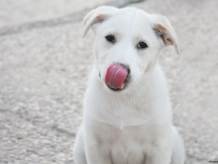

Ingredients
- 1 cup water
- ¼ cup olive oil
- 1 ¼ cups whole wheat flour
- 1 ¼ cups unbleached white flour
- ½ cup soy flour
- 1 ½ teaspoons dry yeast
- ¼ cup dried blueberries - If they are big, have an adult chop them into smaller pieces for you. Dried blueberries are sticky (like raisins), so they will stick to the knife.
Directions
- Prepare the cookie sheet
- Spray a couple of cookie sheets lightly with cooking oil spray.

- Mix the Dough – Use a mixer or a bread machine.
- Mixer - Mix the dry ingredients in a large bowl. (Use a dough hook on the mixer.) Add the water and oil and mix until you have a nice dough.
- Bread machine Place all ingredients in your bread machine on the dough cycle. Remove when the dough is finished and the bread machine beeps.

- Cut out the bones
- Divide the dough into 3 portions.
- Sprinkle about ¼ cup of flour on a large cutting board.
- Using a rolling pin, roll the dough until it is about ¼” thick.
- Turn the dough to make sure that both sides have enough flour to roll easily.
- Cut out the dog bones with a dog bone cookie cutter. (Dip the cookie cutter into a bowl of flour between cuts.) You will have leftover pieces of dough. Just put them together and roll them into a ¼” sheet of dough to make more bones.
- Place the bones on the cookie sheets. (You can use a thin metal spatula to do this.)

- Let the dog bones rise in a warm place.
- Cover the dog bones (with a clean dish towel) and let them sit in a warm place for 1 hour.
- In the winter, heat the oven to 175 degrees for 5 minutes, then turn it off. You can now place the dog bones in the warm oven to rise, for 1 hour.

- Bake the bones.
- Bake at 275 degrees F for 60 minutes, until the dog bones are a light, golden brown. (You may have to turn them once while they are baking—to brown the other side.)

Dry overnight - Turn off the oven and let the dog bones sit in the oven overnight. This will complete the drying process. When done, they will be dry and very hard.
Storage - Store the dog bones in a cool, dry place with a tight cover (up to 30 days). For longer storage, keep the dog bones in the refrigerator or freezer.

Peanut Butter Dog Bones
All dogs love peanut butter.
This peanut butter dog treat recipe is a great one for you to try, because the dough is so easy to work with.
Mom or Dad - If you are working with preschoolers, you will probably want to roll the dough, as this will be the most difficult part. Have your young child or children cut out the bone shapes with a larger dog bone cookie cutter.

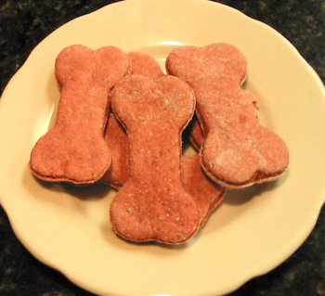

Ingredients
2 cups whole wheat flour
2 ½ cups unbleached flour
¼ cup wheat germ or wheat bran
1 1/2 teaspoons dry yeast
1/2 cup peanut butter
1 1/2 cups water

Directions
- Prepare the cookie sheet
- Spray a couple of cookie sheets lightly with cooking oil spray.

- Mix the Dough – Use a mixer or a bread machine.
- Mixer - Mix the dry ingredients in a large bowl. (Use a dough hook on the mixer.) Add the peanut butter and water, and mix until you have a nice dough.
- Bread machine Place all ingredients in your bread machine on the dough cycle. Remove when the dough is finished and the bread machine beeps.

- Cut out the bones
- Divide the dough into 3 portions.
- Sprinkle about ¼ cup of flour on a large cutting board.
- Using a rolling pin, roll the dough until it is about ¼” thick.
- Turn the dough to make sure that both sides have enough flour to roll easily.
- Cut out the dog bones with a dog bone cookie cutter. (Dip the cookie cutter into a bowl of flour between cuts.) You will have leftover pieces of dough. Just put them together and roll them into a ¼” sheet to make more bones.
- Place the bones on the cookie sheets. (You can use a thin metal spatula to do this.)

- Let the dog bones rise in a warm place.
- Cover the dog bones (with a clean dish towel) and let them sit in a warm place for 1 hour.
- In the winter, heat the oven to 175 degrees for 5 minutes, then turn it off. You can now place the dog bones in the warm oven to rise, for 1 hour.
- Bake the bones.
- Bake at 275 degrees F for 60 minutes, until the dog bones are a light, golden brown. (You may have to turn them once while they are baking—to brown the other side.)

Dry overnight - Turn off the oven and let the dog bones sit in the oven overnight. This will complete the drying process. When done, they will be dry and very hard.
Storage - Store the dog bones in a cool, dry place with a tight cover (up to 30 days). For longer storage, keep the dog bones in the refrigerator or freezer.

Crunchy Cheese Dog Bones
Crunchy Cheese Dog Bones use Parmesan cheese and bacon bits to give them a cheesy taste.
They smell REALLY good in the oven, too.

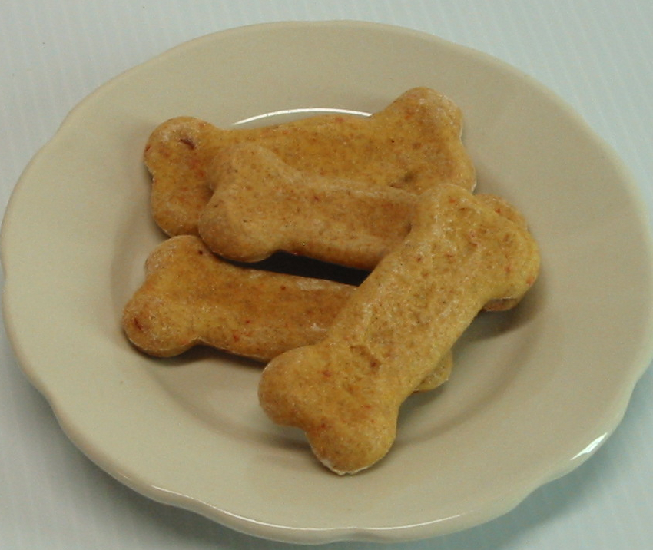
Crunchy Cheese Dog Bones
Ingredients
- 1 cup water
- ¼ cup vegetable oil
- 1 ½ cups whole wheat flour
- 1 ½ cups unbleached white flour
- 1 ½ teaspoons dry yeast
- 3 tablespoons parmesan cheese or cheddar cheese powder
- 2 tablespoons bacon bits

Directions
- Prepare the cookie sheet
- Spray a couple of cookie sheets lightly with cooking oil spray.

- Mix the Dough – Use a mixer or a bread machine.
- Mixer - Mix the dry ingredients in a large bowl. (Use a dough hook on the mixer.) Add the water and oil, and mix until you have a nice dough.
- Bread machine Place all ingredients in your bread machine on the dough cycle. Remove when the dough is finished and the bread machine beeps.

- Cut out the bones
- Divide the dough into 3 portions.
- Sprinkle about ¼ cup of flour on a large cutting board.
- Using a rolling pin, roll the dough until it is about ¼” thick.
- Turn the dough to make sure that both sides have enough flour to roll easily.
- Cut out the dog bones with a dog bone cookie cutter. (Dip the cookie cutter into a bowl of flour between cuts.) You will have leftover pieces of dough. Just put them together and roll them into a ¼” sheet to make more bones.
- Place the bones on the cookie sheets. (You can use a thin metal spatula to do this.)

- Let the dog bones rise in a warm place.
- Cover the dog bones (with a clean dish towel) and let them sit in a warm place for 1 hour.
- In the winter, heat the oven to 175 degrees for 5 minutes, then turn it off. You can now place the dog bones in the warm oven to rise, for 1 hour.
- Bake the bones.
- Bake at 275 degrees F for 60 minutes, until the dog bones are a light, golden brown. (You may have to turn them once while they are baking—to brown the other side.)

Dry overnight - Turn off the oven and let the dog bones sit in the oven overnight. This will complete the drying process. When done, they will be dry and very hard.
Storage - Store the dog bones in a cool, dry place with a tight cover (up to 30 days). For longer storage, keep the dog bones in the refrigerator or freezer.

Carob Dog Bones
Carob tastes almost like chocolate.

Dogs don’t know the difference between carob and chocolate, so if you make these Carob Dog Bones, your dog will think that he is eating chocolate dog bones.

Carob is good for dogs, but chocolate can hurt your dog. So if you want to treat your dog--make pretend chocolate bones and use carob.

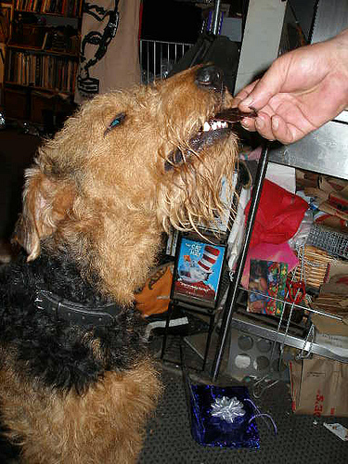

Ingredients
- 1 cup water
- ¼ cup olive oil
- 1 ½ cups whole wheat flour
- 1 ½ cups unbleached white flour
- 1 ½ teaspoons dry yeast
- ¼ cup carob powder
Directions
- Prepare the cookie sheet
- Spray a couple of cookie sheets lightly with cooking oil spray.

- Mix the Dough – Use a mixer or a bread machine.
- Mixer - Mix the dry ingredients in a large bowl. (Use a dough hook on the mixer.) Add the water and oil, and mix until you have a nice dough.
- Bread machine - Place all ingredients in your bread machine on the dough cycle. Remove when the dough is finished and the bread machine beeps.

- Cut out the bones
- Divide the dough into 3 portions.
- Sprinkle about ¼ cup of flour on a large cutting board.
- Using a rolling pin, roll the dough until it is about ¼” thick.
- Turn the dough to make sure that both sides have enough flour to roll easily.
- Cut out the dog bones with a dog bone cookie cutter. (Dip the cookie cutter into a bowl of flour between cuts.) You will have leftover pieces of dough. Just put them together and roll them into a ¼” sheet to make more bones.
- Place the bones on the cookie sheets. (You can use a thin metal spatula to do this.)

- Let the dog bones rise in a warm place.
- Cover the dog bones (with a clean dish towel) and let them sit in a warm place for 1 hour.
- In the winter, heat the oven to 175 degrees for 5 minutes, then turn it off. You can now place the dog bones in the warm oven to rise, for 1 hour.
- Bake the bones.
- Bake at 275 degrees F for 60 minutes, until the dog bones are a light, golden brown. (You may have to turn them once while they are baking—to brown the other side.)

Dry overnight - Turn off the oven and let the dog bones sit in the oven overnight. This will complete the drying process. When done, they will be dry and very hard.
Storage - Store the dog bones in a cool, dry place with a tight cover (up to 30 days). For longer storage, keep the dog bones in the refrigerator or freezer.

Chicken Bones
Dogs like the taste of chicken, but real chicken bones can hurt your dog. They can splinter, and sharp bone pieces can hurt your dog’s intestines.
These chicken bones are safe for your dog to eat. She can still enjoy the taste of chicken—without the sharp bone pieces of real bones!

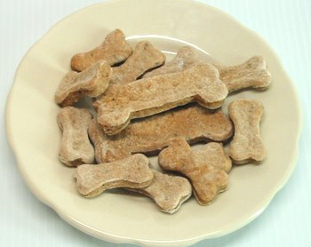
Chicken Dog Bones

Ingredients
- 1 cup chicken broth (can be canned chicken broth)
- ¼ cup olive oil (or you can use vegetable oil)
- 1 ½ cups whole wheat flour
- 1 ½ cups unbleached flour
- 1 ½ teaspoon dry yeast
- 2 tablespoons bran (wheat or oat bran)

Directions
- Prepare the cookie sheet
- Spray a couple of cookie sheets lightly with cooking oil spray.

- Mix the Dough – Use a mixer or a bread machine.
- Mixer - Mix the dry ingredients in a large bowl. (Use a dough hook on the mixer.) Add the chicken broth and oil and mix until you have a nice dough.
- Bread machine Place all ingredients in your bread machine on the dough cycle. Remove when the dough is finished and the bread machine beeps.

- Cut out the bones
- Divide the dough into 3 portions.
- Sprinkle about ¼ cup of flour on a large cutting board.
- Using a rolling pin, roll the dough until it is about ¼” thick.
- Turn the dough to make sure that both sides have enough flour to roll easily.
- Cut out the dog bones with a dog bone cookie cutter. (Dip the cookie cutter into a bowl of flour between cuts.) You will have leftover pieces of dough. Just put them together and roll them into a ¼” sheet to make more bones.
- Place the bones on the cookie sheets. (You can use a thin metal spatula to do this.)

- Let the dog bones rise in a warm place.
- Cover the dog bones (with a clean dish towel) and let them sit in a warm place for 1 hour.
- In the winter, heat the oven to 175 degrees for 5 minutes, then turn it off. You can now place the dog bones in the warm oven to rise, for 1 hour.
- Bake the bones.
- Bake at 275 degrees F for 60 minutes, until the dog bones are a light, golden brown. (You may have to turn them once while they are baking—to brown the other side.)

Dry overnight - Turn off the oven and let the dog bones sit in the oven overnight. This will complete the drying process. When done, they will be dry and very hard.
Storage - Store the dog bones in a cool, dry place with a tight cover (up to 30 days). For longer storage, keep the dog bones in the refrigerator or freezer.

Applesauce Dog Cookies

Apples and applesauce are good for you—and your dog!
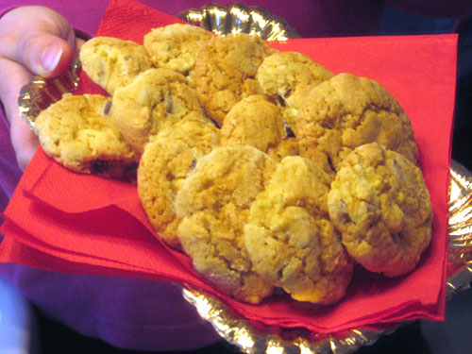
Photo by the Italian voice

Ingredients
- ½ cup shortening
- ¼ cup brown sugar (optional)
- 1 large egg (or 2 small eggs)
- 1 teaspoon vanilla
- ¼ cup water
- ½ cup applesauce
- 1 teaspoon baking soda
- 1 cup unbleached flour
- 3 cups oatmeal

Directions
- Prepare the Dough
- With an electric mixer, cream the egg, sugar, shortening, water, applesauce and vanilla until they are well mixed.
- Slowly add the flour, baking soda, and oatmeal to the wet ingredients. (If you add them too fast, the flour will fly up, out of the bowl.) Mix well.

- Prepare the cookie sheet
- Spray a couple of cookie sheets lightly with cooking oil spray.

- Drop the Cookies
- Using 2 teaspoons (the kind you use for eating, at the table), drop the cookies onto the cookie sheets. Leave a little space between the cookies, so they don’t bake together.

- Bake
- Bake at 375 degrees F for 12-15 minutes, or until the cookies are lightly browned.

Dry overnight - Turn off the oven and let the dog cookies sit in the oven overnight. This will complete the drying process. When done, they will be dry and very hard. (If your dog is old and can’t eat hard cookies, you can skip this step.)
Storage - Store the dog cookies in a cool, dry place with a tight cover (up to 30 days). For longer storage, keep the dog cookies in the refrigerator or freezer.

Doggie Banana Cookies
Dogs love bananas—just like you!
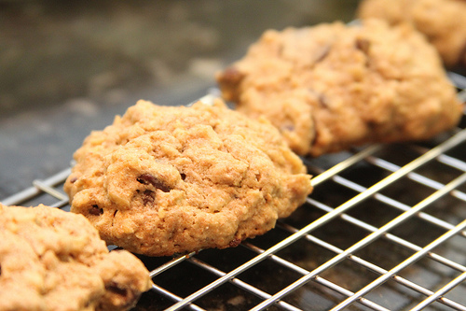
Photo by Gudlyf
Ingredients
- ½ cup shortening
- ¼ cup brown sugar (optional)
- 3 mashed bananas
- 1 teaspoon vanilla
- 2 ½ cups unbleached flour
- 1 teaspoon baking powder
- 1 teaspoon cinnamon

Directions
- Prepare the Dough
- With an electric mixer, cream shortening and sugar until they are well mixed. Add the bananas and vanilla. Mix well.
- Slowly add the flour, baking powder, and cinnamon to the wet ingredients. (If you add them too fast, the flour will fly up, out of the bowl.) Mix well.

- Prepare the cookie sheet
- Spray a couple of cookie sheets lightly with cooking oil spray.

- Drop the Cookies
- Using 2 teaspoons (the kind you use for eating, at the table), drop the cookies onto the cookie sheets. Leave a little space between the cookies, so they don’t bake together.

- Bake
- Bake at 375 degrees F for 12-15 minutes, or until the cookies are lightly browned.

Dry overnight - Turn off the oven and let the dog cookies sit in the oven overnight. This will complete the drying process. When done, they will be dry and very hard. (If your dog is old and can’t eat hard cookies, you can skip this step.)
Storage - Store the dog cookies in a cool, dry place with a tight cover (up to 30 days). For longer storage, keep the dog cookies in the refrigerator or freezer.

Nutty Peanut Dog Cookies
If your dog likes peanuts and peanut butter, she’ll like these dog cookies.

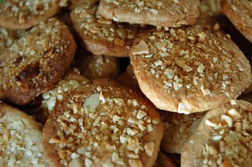

Ingredients
- ¾ cup butter or margarine
- ¼ cup brown sugar (optional)
- 1 egg
- ½ cup water
- 1 teaspoon vanilla
- 3 cups whole wheat flour
- 1 teaspoon baking soda
- 1 teaspoon baking powder
- ½ cup unsalted peanuts (chopped)
- 2 tablespoons unsalted peanuts (chopped into small pieces for the tops of the cookies)

Directions
- Prepare the Dough
- With an electric mixer, cream butter (or margarine) and sugar until they are well mixed. Add the egg, water and vanilla. Mix well.
- Slowly add the flour, baking powder, and baking soda to the wet ingredients. (If you add them too fast, the flour will fly up, out of the bowl.) Mix well.
- Stir in ½ cup of unsalted peanuts and mix well.

- Prepare the cookie sheet
- Spray a couple of cookie sheets lightly with cooking oil spray.

- Drop the Cookies
- Using 2 teaspoons (the kind you use for eating, at the table), drop the cookies onto the cookie sheets. Leave a little space between the cookies, so they don’t bake together.
- Using the last 2 tablespoons of chopped peanuts, sprinkle peanuts onto the top of the cookies. The peanuts will stick better if you brush the tops of the cookies with an egg (beaten with a tablespoon of water) before sprinkling with peanuts.

- Bake
- Bake at 375 degrees F for 15 minutes, or until the cookies are lightly browned.

Dry overnight - Turn off the oven and let the dog cookies sit in the oven overnight. This will complete the drying process. When done, they will be dry and very hard. (If your dog is old and can’t eat hard cookies, you can skip this step.)
Storage - Store the dog cookies in a cool, dry place with a tight cover (up to 30 days). For longer storage, keep the dog cookies in the refrigerator or freezer.

Carob Chip Oatmeal Cookies
Chocolate will make your dog sick, but carob chips are good for your dog. If you use carob powder or carob chips, your dog can still enjoy the taste of (pretend) chocolate!
Don’t these carob chip oatmeal cookies look good?
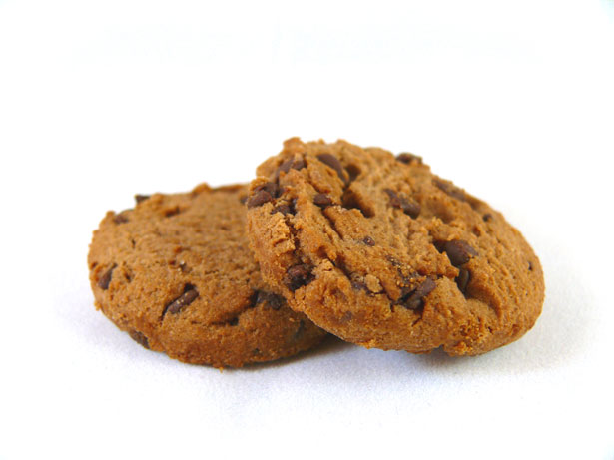
Carob Chip Oatmeal Cookies
Ingredients
- ½ cup whole wheat flour
- ½ cup unbleached white flour
¾ cup oatmeal (old fashioned or quick—either will work)
- ½ teaspoon baking powder
- ½ teaspoon baking soda
- ½ cup shortening
- ¼ cup brown sugar
- 1 egg
- ½ teaspoon vanilla
- ½ cup unsweetened carob chips (Never use chocolate chips!)

Directions
- Mix the Dough
- Mix the flours, oatmeal, baking powder, and baking soda together in a bowl. Set aside.
- With an electric mixer, cream the shortening and sugar together until they are fluffy. Add the egg and vanilla and mix well.
- Slowly add the dry ingredients to the wet ingredients. (If you add them too fast, the flour will fly up out of the bowl.)
- Add the carob chips and mix, just until they are spread evenly in the cookie dough. (You can do this by hand, using a wooden spoon, or use the mixer slowly.)

- Prepare the cookie sheet
- Spray a couple of cookie sheets lightly with cooking oil spray.

- Drop the Cookies
- Using 2 teaspoons (the kind you use for eating), drop the cookies onto the cookie sheets.

- Bake
- Bake at 350 degrees F for 10 minutes, or until the cookies are lightly browned.

Dry overnight - Turn off the oven and let the dog cookies sit in the oven overnight. This will complete the drying process. When done, they will be dry and very hard. (If your dog is old and can’t eat hard cookies, you can skip this step.)
Storage - Store the dog cookies in a cool, dry place with a tight cover (up to 30 days). For longer storage, keep the dog cookies in the refrigerator or freezer.

Bunny Chaser Carrot Cookies

Does your dog like carrots? If so, she will love these cookies!

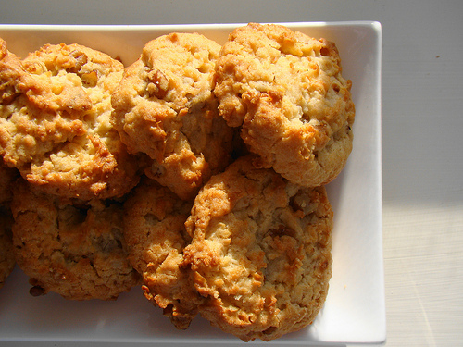
Courtesy of norwichnuts
Ingredients
- 1 egg
- ¼ cup sugar
- ½ cup shortening
- 1 teaspoon vanilla
- 2 cups unbleached flour
- 2 teaspoons baking powder
- 1 ¼ cups shredded carrots (Have an adult help you with shredding carrots.)

Directions
- Prepare the Dough
- With an electric mixer, cream the egg, sugar, shortening, and vanilla until they are well mixed.
- Slowly add the flour and baking powder to the wet ingredients. (If you add them too fast, the flour will fly up, out of the bowl.) Mix well.
- Add the shredded carrots, and mix well. (You can do this by hand, using a wooden spoon, or use the mixer, slowly.)

- Prepare the cookie sheet
- Spray a couple of cookie sheets lightly with cooking oil spray.

- Drop the Cookies
- Using 2 teaspoons (the kind you use for eating, at the table), drop the cookies onto the cookie sheets. Leave a little space between the cookies, so they don’t bake together.

- Bake
- Bake at 375 degrees F for 15 minutes, or until the cookies are lightly browned.

Dry overnight - Turn off the oven and let the dog cookies sit in the oven overnight. This will complete the drying process. When done, they will be dry and very hard. (If your dog is old and can’t eat hard cookies, you can skip this step.)
Storage - Store the dog cookies in a cool, dry place with a tight cover (up to 30 days). For longer storage, keep the dog cookies in the refrigerator or freezer.

Peanut Butter Oatmeal Cookies

Dogs LOVE peanut butter, and oatmeal is good for their hearts.
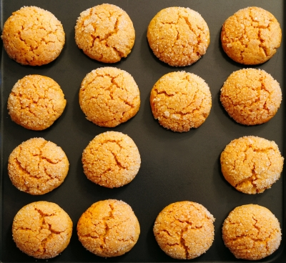

Ingredients
- ½ cup whole wheat flour
- ½ cup unbleached white flour
- ¾ cup oatmeal (old fashioned or quick—either will work)
- ½ teaspoon baking powder
- ½ teaspoon baking soda
- ¼ cup shortening
- ¼ cup peanut butter
- ¼ cup brown sugar (optional)
- 1 egg
- ½ teaspoon vanilla
- ½ cup chopped peanuts
Directions
- Mix the Dough
- Mix the flours, oatmeal, baking powder, and baking soda together in a bowl. Set aside.
- With an electric mixer, cream the shortening, peanut butter and sugar together until they are fluffy. Add the egg and vanilla and mix well.
- Slowly add the dry ingredients to the wet ingredients. (If you add them too fast, the flour will fly up out of the bowl.)
- Add the chopped peanuts and mix, just until they are spread evenly in the cookie dough. (You can do this by hand, using a wooden spoon, or use the mixer slowly.)

- Prepare the cookie sheet
- Spray a couple of cookie sheets lightly with cooking oil spray.

- Drop the Cookies
- Using 2 teaspoons (the kind you use for eating, at the table), drop the cookies onto the cookie sheets.

- Bake
- Bake at 350 degrees F for 10 minutes, or until the cookies are lightly browned.

Dry overnight - Turn off the oven and let the dog cookies sit in the oven overnight. This will complete the drying process. When done, they will be dry and very hard. (If your dog is old and can’t eat hard cookies, you can skip this step.)
Storage - Store the dog cookies in a cool, dry place with a tight cover (up to 30 days). For longer storage, keep the dog cookies in the refrigerator or freezer.

Sunflower Seed Pumpkin Cookies
Pumpkin is good for your dog’s digestive system. It will keep your dog’s tummy happy!

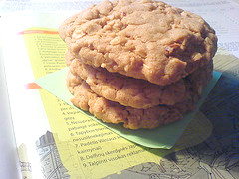

Ingredients
- 1 teaspoon baking soda
- 1 tablespoon milk
- 1 egg
- ¼ cup sugar (optional)
- ½ cup vegetable oil
- 1 teaspoon vanilla
- 1 cup cooked canned pumpkin
- 2 ¼ cups unbleached flour
- 2 teaspoons baking powder
- 1 teaspoon cinnamon
- ½ cup sunflower seeds

Directions
- Prepare the Dough
- Dissolve the baking soda in the milk (Use a small bowl).
- With an electric mixer, mix the egg, sugar, oil, vanilla and pumpkin together until they are well mixed.
- Slowly add the dry ingredients (except the sunflower seeds) to the wet ingredients. (If you add them too fast, the flour will fly up, out of the bowl.) Mix well.
- Add the sunflower seeds, and mix well. (You can do this by hand, using a wooden spoon, or use the mixer, slowly.)

- Prepare the cookie sheet
- Spray a couple of cookie sheets lightly with cooking oil spray.

- Drop the Cookies
- Using 2 teaspoons (the kind you use for eating), drop the cookies onto the cookie sheets. Leave a little space between the cookies, so they don’t bake together.

- Bake
- Bake at 350 degrees F for 12 minutes, or until the cookies are lightly browned.

Dry overnight - Turn off the oven and let the dog cookies sit in the oven overnight. This will complete the drying process. When done, they will be dry and very hard. (If your dog is old and can’t eat hard cookies, you can skip this step.)
Storage - Store the dog cookies in a cool, dry place with a tight cover (up to 30 days). For longer storage, keep the dog cookies in the refrigerator or freezer.

Whole Wheat Cranberry Dog Cookies
Whole Wheat Cranberry Dog Cookies sure look good! They have dried cranberries in them, which can be used in your dog treats (instead of raisins).

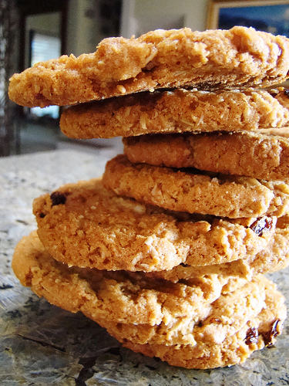
Photo courtesy of norwichnuts
Ingredients
- ¾ cup butter or margarine
- ¼ cup brown sugar (optional)
- 1 egg
- ½ cup water
- 1 teaspoon vanilla
- 3 cups whole wheat flour
- 1 teaspoon baking soda
- 1 teaspoon baking powder
- ½ cup dried cranberries (craisins)

Directions
- Prepare the Dough
- With an electric mixer, cream butter or margarine and sugar until they are well mixed. Add the egg, water and vanilla. Mix well.
- Slowly add the flour, baking powder, and baking soda to the wet ingredients. (If you add them too fast, the flour will fly up, out of the bowl.) Mix well.
- Stir in the dried cranberries and mix well.

- Prepare the cookie sheet
- Spray a couple of cookie sheets lightly with cooking oil spray.

- Drop the Cookies
- Using 2 teaspoons (the kind you use for eating, at the table), drop the cookies onto the cookie sheets. Leave a little space between the cookies, so they don’t bake together.

- Bake
- Bake at 375 degrees F for 15 minutes, or until the cookies are lightly browned.

Dry overnight - Turn off the oven and let the dog cookies sit in the oven overnight. This will complete the drying process. When done, they will be dry and very hard. (If your dog is old and can’t eat hard cookies, you can skip this step.)
Storage - Store the dog cookies in a cool, dry place with a tight cover (up to 30 days). For longer storage, keep the dog cookies in the refrigerator or freezer.

Carob Cookies
Carob is a healthy substitute ingredient for chocolate. Carob is good for both you and your dog.

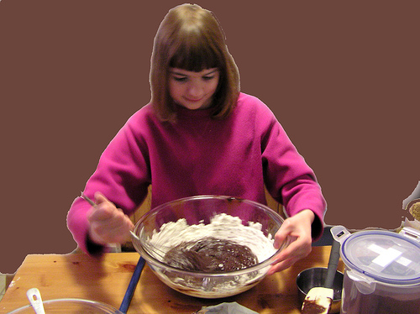
Photo by normanack

Ingredients
- 1 cup shortening
- ¼ cup raw or brown sugar (optional)
- 1 cup milk
- 2 eggs
- 1 teaspoon vanilla
- 1 teaspoons baking soda
- 1 teaspoon baking powder
- 4 cups unbleached flour
- ¼ cup carob powder

Directions
- Prepare the Dough
- With an electric mixer, cream shortening and sugar until they are well mixed. Add the milk, vanilla and eggs and mix well.
- In another bowl, mix the flour, carob powder, baking soda, and baking powder.
- Slowly add the dry flour mixture to the wet ingredients. (If you add this too fast, the flour will fly up, out of the bowl.) Mix well.

- Prepare the cookie sheet
- Spray a couple of cookie sheets lightly with cooking oil spray.

- Drop the Cookies
- Using 2 teaspoons (the kind you use for eating, at the table), drop the cookies onto the cookie sheets. Leave a little space between the cookies, so they don’t bake together.

- Bake
- Bake at 375 degrees F for 12-15 minutes, or until the cookies are lightly browned.

Dry overnight - Turn off the oven and let the dog cookies sit in the oven overnight. This will complete the drying process. When done, they will be dry and very hard. (If your dog is old and can’t eat hard cookies, you can skip this step.)
Storage - Store the dog cookies in a cool, dry place with a tight cover (up to 30 days). For longer storage, keep the dog cookies in the refrigerator or freezer.

No-Bake Dog Cookies
This recipe requires that you use a pan on top of the stove. Get an adult to help you with this part.

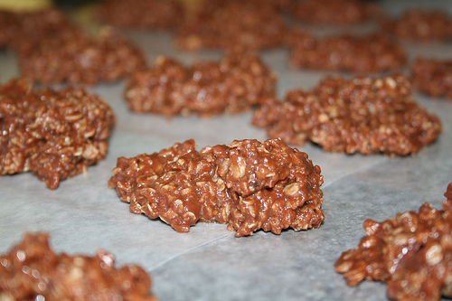
Photo by alibree

Ingredients
- 1 stick butter or margarine
- ¼ cup brown sugar (optional)
- 2 tablespoons carob powder
- ½ cup milk
- 1 cup bran (rice, wheat or oat bran)
- 1 cup chopped peanuts or sunflower seeds
- 3 cups oatmeal

Directions
- Cook on the Stove
- In a saucepan, melt the butter or margarine. Add the carob powder, sugar and milk. Stir until everything is dissolved and mixed well. Remove from the heat, and turn the stove off.
- Add the bran, nuts or seeds and oatmeal. Mix well.

- Prepare the cookie sheet
- Put a piece of waxed paper on a cookie sheet.

- Drop the Cookies
- Using 2 teaspoons (the kind you use for eating, at the table), drop the cookies onto the cookie sheets.

- Cool
- Cool in the refrigerator or freezer until the cookies harden. Serve.

Storage - Store the dog cookies in the refrigerator, with a tight cover (up to 30 days). For longer storage, keep the dog cookies in the freezer.

Anise Cookie Press Cookies
Cookie press cookies don’t bake very long. Notice that they just get a little brown around the edges when they are done.
These cookies are cooling (after they were baked) on a cookie rack.

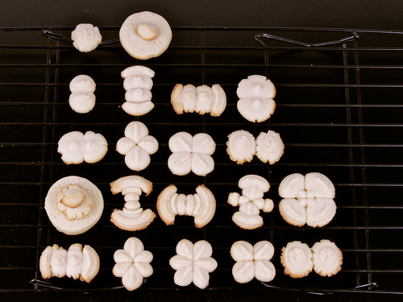
Photo by oskay

Ingredients
- 1 cup butter or margarine (softened)
- 2 tablespoons sugar
- 1 egg
- 1 teaspoon anise extract or 1 tablespoon anise seeds
- 2 2/3 cups unbleached flour
- 1 teaspoon baking powder

Directions
- Mix the Dough
- With an electric mixer, cream the butter (or margarine) and sugar until fluffy.
- Add the egg and mix well.
- In a small bowl, stir together the flour, anise seeds and baking powder.
- Slowly add the flour mixture to the egg mixture and mix until the dough is smooth.

- Use the Cookie Press to make the cookies.
- Spoon half of the dough into the cookie press, and then repeat.
- Choose a design that you like. (Try a couple different plates, and then pick the one that you like best.)
- Squeeze the dough onto an ungreased cookie sheet. This may take some practice. You need to use enough dough—but not too much! Use one click for each cookie. Carefully lift the cookie press—straight up, so the cookie doesn’t get a funny shape.
- Leave a little room between cookies on the cookie sheet.

- Bake the cookies.
- Bake the dog cookies at 400 degrees F for 8 minutes

Dry Overnight - Turn off the oven and let the dog cookies sit in the oven overnight. This will complete the drying process. When done, they will be dry and very hard.
Storage - Store the dog cookies in a cool, dry place with a tight cover (up to 30 days). For longer storage, keep the dog cookies in the refrigerator or freezer.

Banana Cookie Press Cookies
Bananas and banana flavor are always a favorite for dogs!
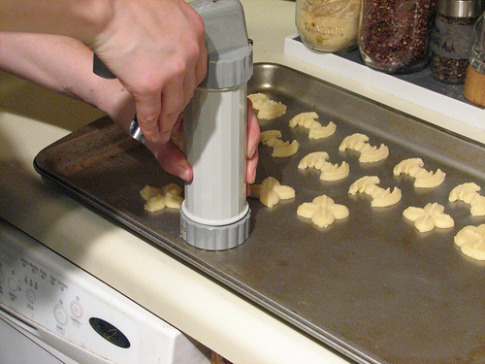
Photo by oskay
Ingredients
- 1 cup butter or margarine (softened)
- ¼ cup sugar
- 1 egg
- 1 teaspoon banana extract
- 2 2/3 cups unbleached flour
- 1 teaspoon baking powder

Directions
- Mix the Dough
- With an electric mixer, cream the butter (or margarine and sugar until fluffy.
- Add the egg and banana extract and mix well.
- In a small bowl, stir together the flour and baking powder.
- Slowly add the flour mixture to the egg mixture and mix until the dough is smooth.

- Use the Cookie Press to make the cookies.
- Spoon half of the dough into the cookie press, and then repeat.
- Choose a design that you like. (Try a couple different plates, and then pick the one that you like best.)
- Squeeze the dough onto an ungreased cookie sheet. This may take some practice. You need to use enough dough—but not too much! Use one click for each cookie. Carefully lift the cookie press—straight up, so the cookie doesn’t get a funny shape.
- Leave a little room between cookies on the cookie sheet.

- Bake the cookies.
- Bake the dog cookies at 400 degrees F for 8 minutes

Dry overnight - Turn off the oven and let the dog cookies sit in the oven overnight. This will complete the drying process. When done, they will be dry and very hard.
Storage - Store the dog cookies in a cool, dry place with a tight cover (up to 30 days). For longer storage, keep the dog cookies in the refrigerator or freezer.

Beefy Cookie Press Cookies

Put some food coloring in your dough if you want to make colored cookies.
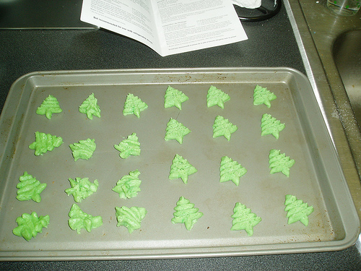
Photo by Joelk75
Ingredients
- 1 cup butter or margarine (softened)
- 2 tablespoons sugar
- 1 egg
- 1 teaspoon beef bouillon
- 2 2/3 cups unbleached flour
- 1 teaspoon baking powder

Directions
- Mix the Dough
- With an electric mixer, cream the butter (or margarine) and sugar until fluffy.
- Add the egg and mix well.
- In a small bowl, stir together the flour, baking powder and beef bouillon.
- Slowly add the flour mixture to the egg mixture and mix until the dough is smooth.

- Use the Cookie Press to make the cookies.
- Spoon half of the dough into the cookie press, and then repeat.
- Choose a design that you like. (Try a couple different plates, and then pick the one that you like best.)
- Squeeze the dough onto an ungreased cookie sheet. This may take some practice. You need to use enough dough—but not too much! Use one click for each cookie. Carefully lift the cookie press—straight up, so the cookie doesn’t get a funny shape.
- Leave a little room between cookies on the cookie sheet.

- Bake the cookies.
- Bake the dog cookies at 400 degrees F for 8 minutes

Dry overnight - Turn off the oven and let the dog cookies sit in the oven overnight. This will complete the drying process. When done, they will be dry and very hard.
Storage - Store the dog cookies in a cool, dry place with a tight cover (up to 30 days). For longer storage, keep the dog cookies in the refrigerator or freezer.

Cheese Cookie Press Cookies
To make your cheese cookie press cookies look like this, sprinkle bacon bits on top of them before you bake them.
If you mix an egg with 1 tablespoon of water and brush the egg onto the cookies first, the bacon bits will stick better.

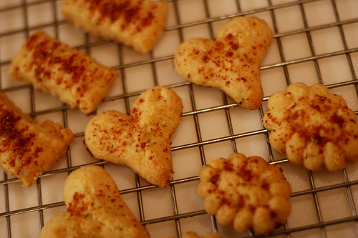
Photo by pbody
Ingredients
- 1 cup butter or margarine (softened)
- 1 egg
- ¼ cup cheddar cheese powder or parmesan cheese
- 2 2/3 cups unbleached flour
- 1 teaspoon baking powder

Directions
- Mix the Dough
- With an electric mixer, cream the butter (or margarine) until fluffy.
- Add the egg and mix well.
- In a small bowl, stir together the flour, cheese and baking powder.
- Slowly add the flour mixture to the egg mixture and mix until the dough is smooth.

- Use the Cookie Press to make the cookies.
- Spoon half of the dough into the cookie press, and then repeat.
- Choose a design that you like. (Try a couple different plates, and then pick the one that you like best.)
- Squeeze the dough onto an ungreased cookie sheet. This may take some practice. You need to use enough dough—but not too much! Use one click for each cookie. Carefully lift the cookie press—straight up, so the cookie doesn’t get a funny shape.
- Leave a little room between cookies on the cookie sheet.

- Bake the cookies.
- Bake the dog cookies at 400 degrees F for 8 minutes

Dry overnight - Turn off the oven and let the dog cookies sit in the oven overnight. This will complete the drying process. When done, they will be dry and very hard.
Storage - Store the dog cookies in a cool, dry place with a tight cover (up to 30 days). For longer storage, keep the dog cookies in the refrigerator or freezer.

Carob Cookie Press Dog Cookies

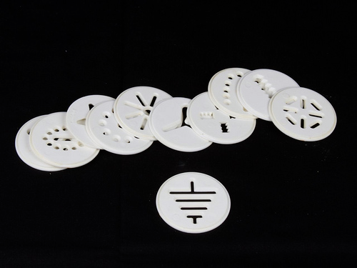
These are the plates that fit onto the cookie press.
They make different patterns for your cookies.

Ingredients
- ¾ cup butter or margarine (softened)
- 2 tablespoons shortening
- ¼ cup sugar
- 1 egg
- 1 teaspoon vanilla
- 1 ¼ cups unbleached flour
- 1 cup whole wheat flour
- 6 tablespoons carob powder

Directions
- Mix the Dough
- With an electric mixer, cream the butter (or margarine), shortening and sugar until fluffy.
- Add the egg and vanilla and mix well.
- In a small bowl, stir together the flours and carob powder.
- Slowly add the flour mixture to the egg mixture and mix until the dough is smooth.

- Use the Cookie Press to make the cookies.
- Spoon half of the dough into the cookie press, and then repeat.
- Choose a design that you like. (Try a couple different plates, and then pick the one that you like best.)
- Squeeze the dough onto an ungreased cookie sheet. This may take some practice. You need to use enough dough—but not too much! Use one click for each cookie. Carefully lift the cookie press—straight up, so the cookie doesn’t get a funny shape.
- Leave a little room between cookies on the cookie sheet.

- Bake the cookies.
- Bake the dog cookies at 400 degrees F for 8 minutes

Dry Overnight - Turn off the oven and let the dog cookies sit in the oven overnight. This will complete the drying process. When done, they will be dry and very hard.
Storage - Store the dog cookies in a cool, dry place with a tight cover (up to 30 days). For longer storage, keep the dog cookies in the refrigerator or freezer.

Chicken Cookie Press Cookies

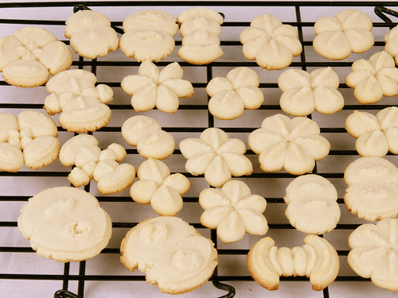
Photo by oskay

Ingredients
- 1 cup butter or margarine (softened)
- 2 tablespoons sugar
- 1 egg
- 1 teaspoon chicken bouillon
- 2 2/3 cups unbleached flour
- 1 teaspoon baking powder

Directions
- Mix the Dough
- With an electric mixer, cream the butter (or margarine) and sugar until fluffy.
- Add the egg and mix well.
- In a small bowl, stir together the flour, chicken bouillon and baking powder.
- Slowly add the flour mixture to the egg mixture and mix until the dough is smooth.

- Use the Cookie Press to make the cookies.
- Spoon half of the dough into the cookie press, and then repeat.
- Choose a design that you like. (Try a couple different plates, and then pick the one that you like best.)
- Squeeze the dough onto an ungreased cookie sheet. This may take some practice. You need to use enough dough—but not too much! Use one click for each cookie. Carefully lift the cookie press—straight up, so the cookie doesn’t get a funny shape.
- Leave a little room between cookies on the cookie sheet.

- Bake the cookies.
- Bake the dog cookies at 400 degrees F for 8 minutes

Dry overnight - Turn off the oven and let the dog cookies sit in the oven overnight. This will complete the drying process. When done, they will be dry and very hard.
Storage - Store the dog cookies in a cool, dry place with a tight cover (up to 30 days). For longer storage, keep the dog cookies in the refrigerator or freezer.

Oatmeal Cookie Press Dog Cookies

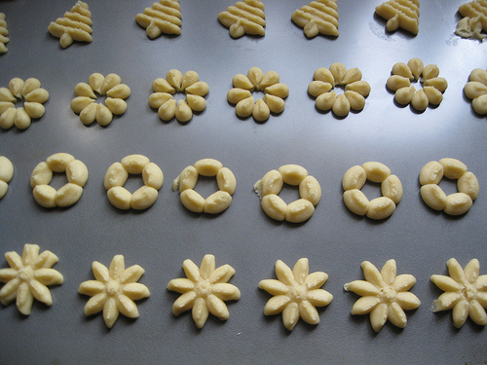
Photo by rayb777

Ingredients
- 1 cup butter or margarine (softened)
- ¼ cup sugar
- 1 egg
- 1 teaspoon vanilla
- 2 cups unbleached flour
- 2/3 cup rolled oats
- 1 teaspoon baking powder
- 1 teaspoon cinnamon

Directions
- Mix the Dough
- With an electric mixer, cream the butter (or margarine) and sugar until fluffy.
- Add the egg and vanilla and mix well.
- In a small bowl, stir together the flour, oats, baking powder and cinnamon.
- Slowly add the flour mixture to the egg mixture and mix until the dough is smooth.

- Use the Cookie Press to make the cookies.
- Spoon half of the dough into the cookie press, and then repeat.
- Choose a design that you like. (Try a couple different plates, and then pick the one that you like best.)
- Squeeze the dough onto an ungreased cookie sheet. This may take some practice. You need to use enough dough—but not too much! Use one click for each cookie. Carefully lift the cookie press—straight up, so the cookie doesn’t get a funny shape.
- Leave a little room between cookies on the cookie sheet.

- Bake the cookies.
- Bake the dog cookies at 400 degrees F for 8 minutes

Dry overnight - Turn off the oven and let the dog cookies sit in the oven overnight. This will complete the drying process. When done, they will be dry and very hard.
Storage - Store the dog cookies in a cool, dry place with a tight cover (up to 30 days). For longer storage, keep the dog cookies in the refrigerator or freezer.

Peanut Butter Cookie Press Cookies
These peanut butter cookie press cookies have some colored sugar sprinkled on them.
If you want to do this with your cookies, sprinkle the sugar on the cookies, just before you bake them.

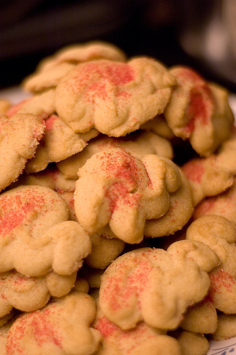
Photo by RBerteig
Ingredients
- ½ cup creamy peanut butter
- ¼ cup butter or margarine
- ¼ cup brown sugar
- 1 egg
- 1 ¼ cup unbleached flour
- 1 teaspoon baking soda

Directions
- Mix the Dough
- With an electric mixer, cream the butter (or margarine), peanut butter and sugar until fluffy.
- Add the egg and mix well.
- In a small bowl, stir together the flour and baking soda.
- Slowly add the flour mixture to the egg mixture and mix until the dough is smooth.

- Use the Cookie Press to make the cookies.
- Spoon half of the dough into the cookie press, and then repeat.
- Choose a design that you like. (Try a couple different plates, and then pick the one that you like best.)
- Squeeze the dough onto an ungreased cookie sheet. This may take some practice. You need to use enough dough—but not too much! Use one click for each cookie. Carefully lift the cookie press—straight up, so the cookie doesn’t get a funny shape.
- Leave a little room between cookies on the cookie sheet.

- Bake the cookies.
- Bake the dog cookies at 400 degrees F for 8 minutes

Dry overnight - Turn off the oven and let the dog cookies sit in the oven overnight. This will complete the drying process. When done, they will be dry and very hard.
Storage - Store the dog cookies in a cool, dry place with a tight cover (up to 30 days). For longer storage, keep the dog cookies in the refrigerator or freezer.

